Br. J. Psychol. (1977), 68, 97--106 Printed in Great Britain 97

The discovery of segments in natural language

J. G. Wolff

The performance of a computer model of linguistic segmentation is described and evaluated when it is used with natural language. It identifies words quite successfully and seems to have some sensitivity to morphs but it performs poorly with structures larger than words. From the language samples, the program extracts most of the sequential redundancy and some of the redundancy due to the unequal frequencies of elements. This accords with the principle of economical coding in cognition (Attneave, 1954; Oldfield, 1954). The process seems also to model certain aspects of how children’s vocabularies grow and the increasing lengths of the words which children acquire. It may have a bearing on the explanation of infantile amnesia and the word transformation effect.

A computer model (program MK10) which was described in a previous paper (Wolff, 1975 a) was intended to show how the segmental structure of a language may be learned by young children despite the apparent absence of consistent physical markers like pause or stress for the boundaries of words and other linguistic segments. The performance of the model was illustrated mainly using artificial languages. The main purpose of this paper is to present and evaluate results from natural language and to relate these results firstly to the principle of economical coding in cognition and secondly to established features of vocabulary growth. Other phenomena and related work are considered in a discussion of the model’s plausibility.
Since there has been some misunderstanding of this point it is as well to emphasize that the problem under attack is not to identify pre-established segments in unsegmented data (see, for example, Reddy, Erman & Neely, 1973) but to discover what segments are implicit in the data. A young child has to discover the segmentation of language rather than merely recognize segments he already knows.

Results from natural language
Three texts have been prepared in the usual manner with all spaces and punctuation omitted. Text 1 (10000 letters) is taken from book 8A of the Ladybird Reading Series. Text 2 (20000 letters) comes from Paul Gallicoe’s novel Jennie. Text 3 (20000 letters) is adult speech taken from transcripts of recordings of the spontaneous speech of children and adults.* The sample contains roughly equal amounts of material from homes classified as ‘professional’ and ‘non-professional’. It is taken to be representative of the kind of speech which young children hear. These texts have been used as data for a variant of the computer program previously described. This version, MK10H, covers the whole sample on every scan and at the end of each scan selects the most frequently occurring contiguous pair of elements (or an arbitrary choice amongst ties). The two versions produce essentially the same results but MK10H has the merit of covering exactly the same sample on every scan. This means that precise frequencies of occurrence of elements in the sample can be obtained which have theoretical uses considered elsewhere.
Small sections (125 words each) of the resulting segmentations are shown in Tables 1, 2 and 3 for Text 1 after 501 scans, Text 2 after 951 scans and Text 3 after 572 scans, respectively. Each segment was printed out with its reference number so that in the full print-out it was possible to trace the full hierarchical structure of every segment. These structures are marked by brackets

* I am grateful to Dr Gordon Wells (School of Education Research Unit, University of Bristol, Lyndale House, 19 Berkeley Square, Bristol BS8 1HF) for making these available.

- PSY 68

98 J. G. Wolff

Table 1. Segmentation of Text 1 by program MK10H (10000 letter sample, 501 scans)

((IT)(IS))(SUMMER)(TIME)(SCHOOL)(IS)(OVER)(AND)(THE)((LONG)(SUMMER))
(HOLIDAY)(IS)(HERE)(JANE)((AND)(PETER))(T)(AL)(K)(ABOUT)(THEIR)
((LONG)(SUMMER))(HOLIDAY)(AND)(WHAT)((THEY)(ARE))(GOING)((TO)(DO))
(((I)(L))(IKE))(SCHOOL)((SAYS)(PETER))(BUT)((I)(AM))(GLAD)(THE)
(HOLIDAY)(HAS)(COM)(E)(YES)((I)(AM))(GLAD)(TOO)((SAYS)(JANE))
(((I)(L))(IKE))(SUNNY)(DAYS)(WHEN)((WE)(HAVE))((NO)(W))(OR)(K)
((TO)(DO))((THERE)(ARE))(SO)(MANY)(NICE)(THING)((ST)(O))(DO)
((IN)(THE))(HOLIDAY)(WHEN)((IT)(IS))(SUNNY)((YES)((SAYS)(PETER)))
(AND)(DADDY)(THINK)((S)(IT))(DOES)(US)(GOOD)((TO)(GET))(OUT)
((IN)(THE))(SUN)((WE)(WILL))(BE)(OUT)(EVERY)(DAY)(WHEN)((THE)(SUN))
((COMES)(OUT))(DO)(YOU)(KNOW)((THERE)(IS))(AN)(OLD)(DONKEY)
((UP)((AT)(THE)))(FARM)(NOW)((ASKS)(JANE))((HE)(IS))(TOO)(OLD)
(TO)(WOR)(K)(PAM)...

Table 2. Segmentation of Text 2 by program MK10H (20000 letter sample, 951 scans)

((HE)(HAD))(WANTED)(TO)(HOLD)((AND)(S))(TRO)(KE)((THE)(KITTEN))
(NANNY)(HAD)(SC)(RE)(AM)((ED)(AND))(THERE)((HAD)(BEEN))
((A)((K1ND)(OF)))(AN)(AW)(FUL)(B)(UMP)(AFTER)(WHICH)(IT)
(((SEEMED)(TO))(HAVE))(TURNED)(FROM)(DAY)((TO)(N))(IGHT)
((AS)(THOUGH))((THE)(S))(UN)(WERE)((GONE)(AND))((IT)(HAD))
(BECOME)(QUIT)(ED)(ARK)(HE)(ACH)((ED)(AND))(SOME)(WHERE)(IT)
(HURT)(HIM)(AS)((IT)(HAD))(((WHEN)(HE))(HAD))(F)(ALL)(EN)(RUNNING)
(AFTER)(AF)(OO)(T)(BALL)(NEAR)(AG)(RA)(VE)(L)(PIL)((E)(AND))
(SC)(RA)(PED)(NEAR)(LY)(ALL)((THE)(S))(K)(IN)((FROM)(THE))(SID)
((E)(OF))(ONE)(LEG)(HE)(((SEEMED)(TO))(BE))((IN)(BED))(NOW)(AND)
(NANNY)(WAS)(THERE)(PE)(ER)((ING)((AT)(HIM)))((IN)(AN))(ODD)( WAY)
((THAT)(IS))(FIRST)((SHE)(WOULD))(BE)(QUIT)((EC)(LOSE))((TO)(HIM))
(SO)(CLOSE)((((THAT)(HE))(COULD))(SEE))(HOW)(WHITE)(HER)(FACE)(WAS)
(INSTEAD)((OF)(IT))(SU)(SU)(AL)(W)(RI)(NK)(LED)(PINK)(COLOU)...

Table 3. Segmentation of Text 3 by program MK10H (20000 letter sample, 572 scans)

(NO)(DARLING)(((NO)(NO))((NO)(NO)))(YES)(WHEN)(THEY)(ARE)
(WAS)(HE)(DY)(OU)(CAN)(NOT)(BEFOR)(E)(OH)((SHE)(S))(NOT)((SHE)(S))
(NOT)(AD)(IR)(TY)(CAT)((ARE)(YOU))(DARLING)(NO)(LEAVE)((MUMMY)(S))
(WAS)(HING)(ALONE)(PLEASE)((MUMMY)(S))((GOT)(TO))(WAS)(HA)(LL)
(THAT)(YES)((THERE)(S))(YOUR)(SO)(CK)(SM)(UM)(MY)(SW)(AS)(HING)
(THEM)((I)(VE))((GOT)(TO))(DO)(ALL)(THAT)(NOW)(YES)(LIND)(AB)
(OUGHT)(YOU)(SO)(CK)((ST)(HE))(Y)(RE)(DI)(R)(TY)(THEY)(VE)((GOT)(TO))
(BE)(WAS)(HE)(D)(PARDON)(NO)((MUMMY)(S))((GOING)(TO))(WAS)(H)(THEM)
(NO)(LIND)(AS)((NOT)((GOING)(TO)))(WAS)(H)(THEM)(NO)(MUMMY)(WAS)(H)
(THEM)(PARDON)(PARDON)(((THAT)(S))(NOT))((YOUR)(B))(RO)(O)(CH)
((THAT)(S))((YOUR)(M))(IC)(ROP)(HONE)(NO)(IT)((IS)(NT))(NO)(YOU)
(WONT)(FALL)(NOW)(STOP)((THAT)(S))(ILL)(Y)(NO)(IS)(EP)(LE)(ASE)
(YES)(IN)((AM)(OMENT))(DEAR)(PARDON)(SH)(OW)(ME)…

Segments in natural language 99

Table 4. The correspondence between printer’s words and structures assigned by MK10H to natural language samples

Text 1 Text 2 Text 3

O F χ ² O F χ ² O E χ ²
Printer’s words marked by a node 116 31 233 101 19 354 96 32 128
Printer’s words not marked by a node 9 94 77 24 106 64 29 93 44
310* 418* 172*

* All values of χ ² have one degree of freedom.

in Tables 1, 2 and 3 only to sufficient depth to show whether or not each printer’s word corresponds to a node.

Evaluation of results

Printer’s words. Table 4 (columns O) summarizes the correspondence between printer’s words and nodes assigned to the text by the program. In Text 3 the contractions like ‘Mummy’s’, ‘I’ve’, ‘there’s’, were each counted as two words. ‘Won’t’ and ‘Mummy’s’ in the possessive sense were each counted as one word. The null hypothesis chosen for the purpose of a assessing the statistical significance of these results was that the structures had been assigned to the text in random order. Accordingly, to each 125-word sample the full hierarchical structures assigned by MKIOH (not merely those shown in Tables 1, 2 and 3) were reassigned in a random order. For each sample the most ‘successful’ of three such ‘segmentations’ formed the basis for the expected values shown in Table 4 (columns E). The values of chi squared calculated from these observed and expected frequencies and shown in Table 4 allow the null hypothesis to be rejected with confidence in all three cases (P ≤ 0.01).

Errors in identifying words. Experience of running MKIO on artificial texts suggests that errors arise from three main sources: too small a sample, insufficient processing and the existence of high frequency letter sequences bridging word boundaries. Without repeated and expensive processing of natural language texts under varying conditions it is not easy to establish the origins of particular errors but tentative assignments may be made. Thus where a word is merely fragmented (e.g. (AW)(FUL) in Table 2) it is likely that longer processing will correct the error. It often happens in the early stages of processing that a high frequency sequence like TH results in the wrong segmentation of a sequence like... WHATHE... However when WHAT and HE have been built up this error is corrected. A possible example of this type of error in Table 2 is the sequence (QUIT)(ED)(ARK). If the sample is large enough for QUITE and DARK to occur in a range of other contexts then they will be built up by further processing and this error will be corrected. If the sample is too small then no amount of additional processing will correct the error. Much the same interpretation applies to the sequence (PE)(ER)((ING)((AT)(HIM))) in Table 2. Whether or not this error is corrected is likely to depend on sample size.
But there is a type of error described in the previous paper which may be termed a ‘run-on’ error and which is not corrected either by increasing the sample size or extending the processing. An example from Table 2 is the sequence (AF)(OO)(T)(BALL). The element (AF) is formed as part of the word AFTER and its presence in the dictionary of elements means that the sequence AFOOT will always be wrongly segmented because the program always seeks the largest element which matches a given letter sequence — in this case AF is preferred to A. An

4-2

100 J. G. Wolff

example from Text I (not shown in Table 1) is the sequence....
HEISTOOOLDFORTHATNOWEMUSTNOTGETONHISBACK... which is segmented as
((HE)(IS))(TOO)(OLD)(FOR)(THAT)((NO)(W))(E)(MUST)(NOT)(GET)(ON)(HIS)(BACK).
It is interesting that in reading this text one is apt to make the same ‘run-on’ error—to read
NOW rather than NO WE....

Other structures. There is some evidence, from an examination of the internal structures assigned to words, that MK10 is sensitive to linguistic structures smaller than words. Examples from Text 1 (not all shown in Table 1) are ((GO)(ING)), ((TELL)(S)), ((GO)(ES)), ((DO)(ES)) and ((DONKEY)(S)) in which morphs are marked by the program. It is also noticeable that a number of the errors made by the program involve the mis-assignment of the terminal S on verbs and plurals, e.g. (THING)((ST)(O))(DO), (THINK)((S)(IT)), (LOVE)((S)(HIM)), (GIVE)((STHE)(M)), (EAT)(SF)(R)(OM), etc. These are clear errors but they suggest that the program is sensitive to the division recognized by linguists between a verb or noun and the terminal S. There are however other cases, e.g. ((S)(AYS))((AS)(KS)) and ((COM)(ES)) where the conventional divisions are not marked.
Program MK10 has now been run sufficiently far on natural language to be able to say that, in its present form, it performs poorly in identifying linguistic structures larger than words. Some coherent noun phrases and prepositional phrases are picked out (e.g. ((THE)(DONKEY)), ((FOR)(HIM)), etc.) but conventional groupings are often violated (e.g. (((TO)(THE))(STABLE)), ((I)(AM))(GLAD), (((SAYS)(PETER))(I)), etc.). The tentative reasons advanced here for this relative failure are these:
1. The process almost certainly needs to operate in conjunction with some kind of classification process. The main reason for this is that combinations of specific words are likely to occur so very infrequently that a clustering process based on conjoint frequencies will never get very far whereas particular combinations of classes of words may be expected to occur more frequently. The details of the structures formed above word level are likely to be influenced by the classification process in ways which cannot at present be specified.
2. Whereas the distributional reality of words without reference to meanings has been demonstrated it may be that the forms taken by larger structures are influenced partly by intralinguistic relations and partly by relations existing between intra- and extra-linguistic entities.
3. MK10 suffers from much the same deficiencies as simple phrase structure grammars (Chomsky, 1957; Postal, 1964): it cannot handle recursive structures (e.g. ‘Roger, Jane, Liz... and John’) or discontinuous constituents (e.g. ‘If…then…’). The latter problem is considered in Wolff (1975 b).

Redundancy
After 501 scans program MK10H had 527 elements in store and had divided the 10000 letters of Text 1 into 2548 segments. A message using an ‘alphabet’ of 527 elements requires not less than ten bits per element (10 > log₂ 527 > 9), so this text could be transmitted or stored using 2548 × 10 = 25480 bits. If the text were transmitted simply as alphabetic characters, each one requiring not less than five bits (5 > log₂ 26 > 4), then 10000 × 5 = 50000 bits would be required. A saving of 49 per cent has been achieved. Similar calculations for Text 2 and 3 show savings of 41 and 37 per cent respectively.
A slightly greater saving would probably have been effected if either 512 or 1024 elements were in store so that nine or ten bits per element could be used without wastage (log₂ 512 = 9; log₂ 1024 = 10). Alternatively some additional coding process, such as that described by Edwards (1969, pp. 60-63), could be employed to avoid this wastage.
The savings obtained are not far short of the estimated figure of 50 per cent for the sequential

Segments in natural language 101

redundancy of English given by Garner & Carson (1960). It seems that MKIO successfully extracts most of this redundancy from the text but a small part of the saving can be attributed to a reduction of the redundancy due to the unequal frequencies of elements. For example, the redundancy of Text 2 from this source, calculated using the Shannon-Wiener formula (see Edwards, 1969, pp. 42—45), is 11.6 per cent prior to analysis by MKIOH. After 951 scans by MK10H this redundancy has dropped to 6.4 per cent.
In general, the rather dramatic reduction effected by MK10H in the redundancy of natural language texts shows that MK10H is consistent with the principle of economy in cognition put forward by Attneave (1954) and Oldfield (1954).

Vocabulary growth
The ambiguous title of this section refers to the facts of increasing numbers of words in children’s vocabularies and of the increasing size of the words themselves. Both phenomena will be considered.

The rate of acquisition of words
The estimation of children’s (and adults’) vocabularies is fraught with problems (see Seashore & Eckerson, 1940; M. K. Smith, 1941; Ellegård, 1960) but, notwithstanding these difficulties, a broad pattern can be recognized. First words appear at about 12 months. In the following few months new words are acquired slowly but then the pace accelerates dramatically up to about 36 months (Grant, 1915; M. E. Smith, 1926). Throughout the rest of childhood the rate of acquisition of new words seems to be fast without showing much sign of slackening (Magni, 1919; Gansl, 1939; M. K. Smith, 1941; Hamlin, 1944). Gansl suggests that the acquisition curve is smooth while M. K. Smith finds it to be rather irregular. M. K. Smith’s estimate of the rate of acquisition is about 2700 words per year on average throughout childhood. Towards adulthood the rate seems to slacken (Hamlin, 1944) and decline throughout the adult years reaching a relatively low level in old age (Clement & Bourlière, 1959). One of the several problems in estimating someone’s vocabulary is establishing a criterion for ‘knowing’ a word. Receptive and expressive criteria have been employed variously in the literature so the general pattern outlined here is a composite one which is assumed to apply to both receptive and expressive vocabulary.
There is a suggest ion that the rate of acquisition of words is higher in the third year than at any other time. Thus Lenneberg (1967) writes that

An astonishing spurt in the ability to name things occurs at a definite stage in language development. It represents the culmination of a process that unfolds very slowly until the child reaches the age of about 18 months, when he has learned to utter between three and 50 words. Then, suddenly and spontaneously, the process begins to gather momentum. There is a burst of activity at 24 to 30 months, so that by the time the child completes his third year, give or take a few months, he has built up a speaking vocabulary of more than a thousand words and probably understands another 2000 to 3000 words that he has not yet learned to use.
This ‘naming explosion’ is only one of the extraordinary activities which mark the coming of language, perhaps the most human and least understood form of our behaviour. .. (p. 59).

Lenneberg refers to a spurt in the ability to name things rather than to a peak in the rate of growth of vocabulary, probably because nouns predominate in young children’s vocabularies (Pelsma, 1910; Grant, 1915). But it seems from a search of the literature on vocabulary studies (see Dale, 1963, for a bibliography) that the evidence for a peak stems exclusively from M. E. Smith’s (1926) study which deals only with overall vocabulary. Other studies (e.g. Pelsma, 1910; Boyd, 1914; Nice, 1917) do not record vocabularies at sufficiently short intervals to show whether or not a peak occurs in infancy. Smith’s study suffers from being a cross-sectional study: the peak could simply reflect differences between populations at different ages. Her method of estimating vocabulary sizes lacks the sophistication of later studies (see Ellegård, 1960, in particular) and it is possible that a systematic underestimation of the larger vocabularies

102 J. G. Wolff
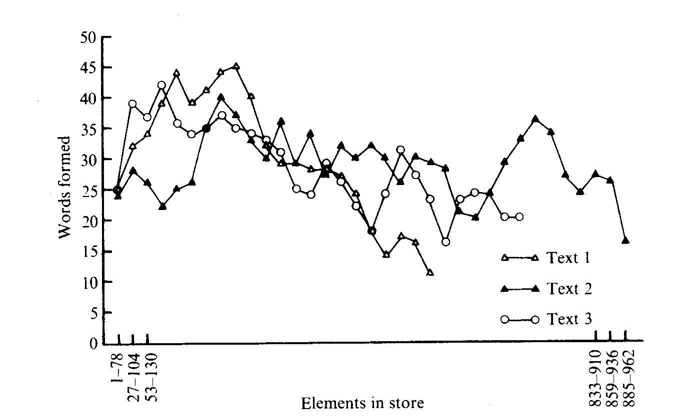

Figure 1. The number of words isolated from Texts 1, 2 and 3 by program MKIOH at different stages of processing.

of the older children could produce an artifactual peak. So it seems that the ‘naming explosion’ should be treated with caution. A less tendentious assertion would be that the rate of acquisition of words in the third year is at least as high as at any other period.
When program MK10H is run on a text, one element is added to the program s dictionary for every scan of the text. If successive scans of the text are assumed to represent equal intervals of time in a child’s development then we may plot the numbers of words formed in successive blocks of scans against the number of scans (or the number of elements in the dictionary) and compare the resulting curve with how children acquire words.
Such plots for Texts 1, 2 and 3 are presented in Fig. 1. To iron out the major irregularities in the data a moving average technique is used so that each point shows the number of words amongst 78 elements consecutive in the program’s dictionary and overlaps with its neighbours by 26 elements. Despite this method of plotting, some fairly marked irregularities remain. It seems from a trial plot of random numbers on the same basis that most of the peaks and troughs can be explained on the assumption that words and non-words are produced in a random sequence. Only the major trends in these three curves should be regarded as significant.
These trends can be summarized as follows. All three curves start at a relatively low level; they rise to their highest level at an early stage and then descend gradually thereafter. This pattern is most marked for Text 1 and least apparent, but still present in the curve for Text 2. The pattern is not unlike the pattern for children’s acquisition of words but with two points of difference: (1) these curves do not start at zero; (2) with the possible exceptions of the curves for Text 1 and Text 3 there is not much sign of a plateau corresponding to the previously noted plateau in the rate of acquisition of words during childhood. As will be suggested below, it may be that both these differences can be regarded as artifacts of the modeling process.
Why should the rate of acquisition of words by both children and the program follow this general pattern? A tentative explanation for both cases follows.
In children the acquisition pattern must be influenced in part by the physical maturation of the brain but in this discussion this influence will be ignored. The explanation of the form of the acquisition curve offered here is based on the segmentation process embodied in program MK10H, described previously (Wolff, 1975 a). It is assumed that babies are equipped with minimal perceptual elements or analysers of some kind and it seems reasonable to suppose that

Segments in natural language 103

these are considerably smaller than words. In the first few months much of the ‘data processing’ effort will be concerned with building composite elements from these minimal elements and a child will not show much sign of ‘knowing’ any words until he starts to assemble these composite elements into words. Hence the interval between birth and the advent of first words. In the next few months the acquisition of words will be slow because a limited variety of building blocks are available and most of the processing is still concerned with creating new building blocks. As more become available the rate of acquisition of words increases.
The initial acceleration in the isolation of words by MK10H can be explained in this kind of way. For example, the formation of the element ING means that SING, GOING and THING can all be formed relatively easily. In a similar way the formation of GO, itself a word, facilitates the formation of GOES and TH enters into THE, WITH, THEM, etc. The program differs from the child in that alphabetic characters are probably much closer to being words than are the child’s minimal elements; indeed, two letters (A and I) are themselves whole words. This is why the program’s curves do not start from zero.
Following the initial acceleration, the rate of acquisition of words by both child and program
stabilizes and then declines. Two factors seem to be responsible for this:
1. In the program, word combinations start to be formed and they augment the numbers of non-words amongst the elements being formed. One may suppose that in a similar way when children start to combine words, an increasing proportion of their processing ‘effort’ will be concerned with assimilating linguistic patterns larger than words and this will help to stabilize the rate of acquisition of words.
2. There is some evidence that rare words differ in their structure from common words and, given that rare words are recognized later than common words by both program and child (see below), this could explain a slowing in the rate of isolation of words. Thus Kinsbourne & Evens (1970) have found that frequent words contain letter sequences of higher diagram and trigram frequency than rare words. Landauer & Streeter (1973) found that significantly more words could be formed from common four-letter words by changing one letter than from rare four-letter words. In terms of this theory of word acquisition these results mean that common words are formed from a smaller variety of constituents than rare words and so their rate of formation can be greater.
In comparing the child’s acquisition of words with the program’s it is important to emphasize that there are huge differences in the amounts of ‘data’ available in the two cases and in the actual numbers of words isolated. The data available to the program can be literally exhausted of all their words in a way which is hardly possible for the corpus on which the child operates (Zipf, 1935; Howes, 1964). This difference may explain the relatively steep decline in the rate of isolation of words by MKIOH compared with children. Given a corpus more similar in size to that which children are exposed to it may be that MK10H would show a similar plateau.

Word sizes
Figure 2 shows the average length of the words acquired by one child plotted against her age (Grant, 1915). There is a clear increase in the length of words during the second year with signs of a leveling off at the end. Although the data do not extend beyond 26 months we can deduce that the curve must level off at later ages: the rate of increase between 12 and 24 months is 0.125 letters per month and if this rate did not slacken the average length of words acquired when the child was ten would be over 17 letters.
This curve may be compared with the curves in Fig. 3. These show a clear increase in the average sizes of words isolated by the program with similar leveling at later stages. It should be emphasized that this effect is not simply an artifact of the way the program builds larger structures from smaller; after only five scans, words as long as 32 letters could be formed. The effect is almost certainly a reflection of the fact (see Hörmann, 1970, pp. 86—87) that frequency

104 J. G. Wolff
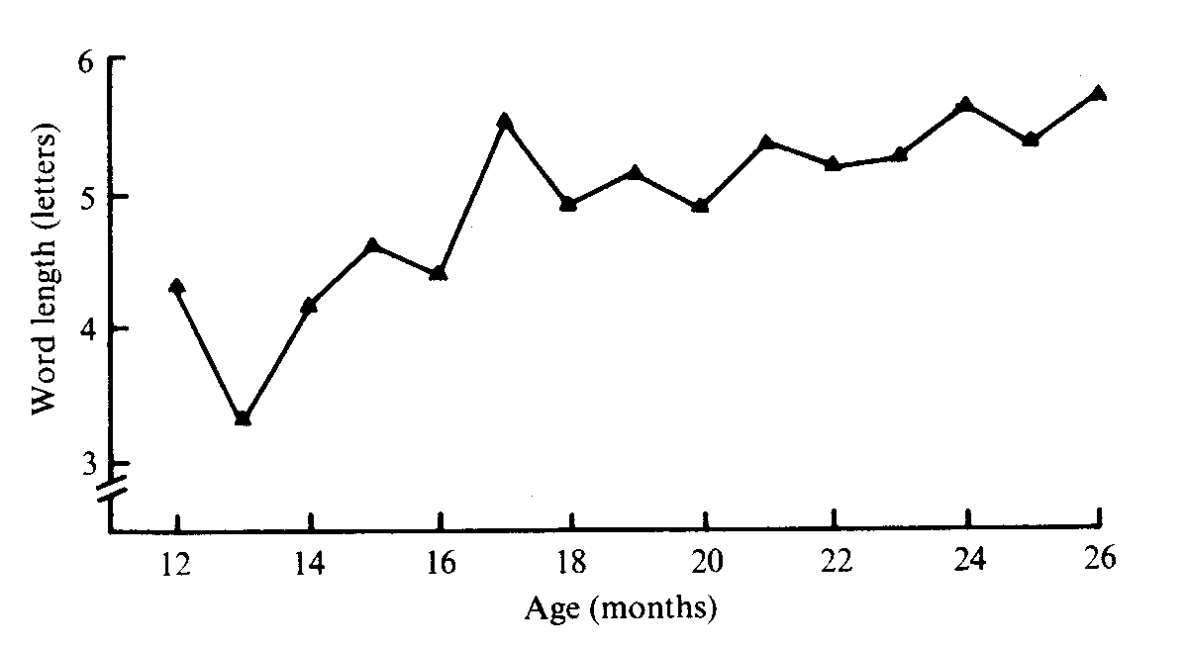

Figure 2. The average lengths of the words acquired by one child at different ages (Grant, 1915).
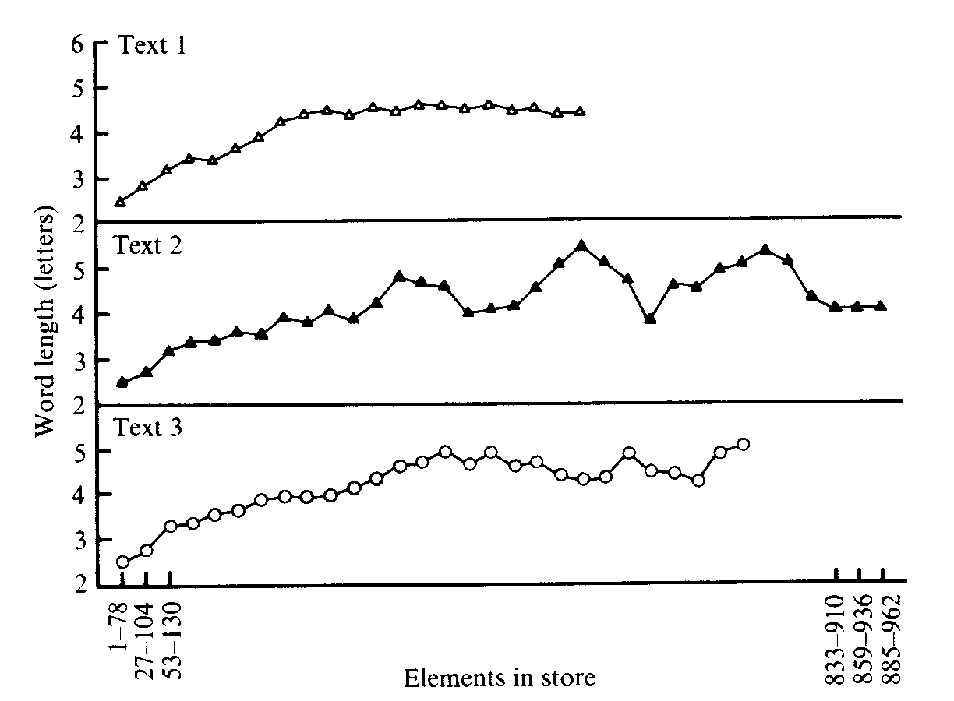

Figure 3. The average lengths of words isolated from Texts 1, 2 and 3 by program MK10H at different stages of processing.

and word length are inversely related. The fact that the lengths of the words acquired by the child increase in this way is indirect but quite clear evidence that children acquire words in at least approximately decreasing order of frequency, in the way that MK10H predicts. The deceleration in the rate of increase simply reflects the fact (Zipf, 1935) that the number of different rare (longer) words is greater than the number of different common (shorter) words.

Discussion
In assessing the strengths and weaknesses of a segmentation model one should of course consider the accuracy with which linguistic segments are isolated. The processes invoked should also be plausible psychologically. If the model can also suggest an explanation of other psychological phenomena then its plausibility is enhanced.
Previous attempts to segment language by distributional means have been made by linguists (Harris, 1955; Gammon, 1969) mainly interested in developing linguistic tools and by psychologists (Stolz, 1965; Olivier, 1968) trying to model psychological processes. The most successful of such attempts and perhaps the most ingenious is Olivier’s which uses a

Segments in natural language 105

shortest-path algorithm borrowed from the field of operational research to find maximum likelihood segmentations of the sample text.
The chi-squared values shown in Table 4 compare favourably with that of 150.6 (1 d.f.) obtained by Olivier from political speeches. This suggests that MK10H is generally the more accurate method for identifying words. The comparison is not a direct one, however, because the texts differ in the two cases as do the methods of calculating chi-squared values.
As a model of psychological processes MK10H has one striking advantage over other methods — on any one scan of the sample it segments the material directly in one left-to-right pass without resort to iterative procedures or the like. This is in keeping with the way we seem generally to be capable of segmenting speech directly as it is heard.
MKIOH also has the merit, mentioned previously (Wolff, 1975 a), of suggesting how frequency information and context may influence pattern recognition. These points and others relating to pattern recognition are considered in detail in another paper in preparation.
The program effects an economical recoding of its input data in keeping with the principle of economy in cognition and it seems to model certain aspects of children’s vocabulary development. It may have a bearing on two other psychological phenomena which may be mentioned briefly.
MK 1OH builds memory structures which are used for the subsequent identification and storage of perceptual events. If similar processes are assumed to operate in cognition generally then we have a natural means of accounting for the phenomenon of infantile amnesia — our inability to remember much from our earliest years. The explanation would be simply that in our first few years we have not built the memory structures needed to interpret and store the events which impinge on us.
Another phenomenon which is explicable in terms of this model is the verbal transformation effect. Warren & Gregory (1958) report that when a word is presented to subjects repeatedly the perception of it may change. A repeating sequence of ‘say’ may be heard after a time as ‘ace’ and then perhaps as ‘say’ again. ‘Rest’ may be heard as ‘tress’, ‘stress -- or even ‘Esther’. These examples correspond to a shift in word boundaries. The effect of repetition is to artificially augment the frequencies of sequences bridging the original word boundaries. This means that a process like MKIOH which is sensitive to high frequency sequences will tend to pick out these alternative sequences as legitimate segments.
One of the assumptions of this work has been that a process for discovering the segmentation of language is part of the process by which a child constructs the grammar of his native language. This model is seen as a step towards a language acquisition model. The data and arguments presented to date are intended to show that the kinds of process put forward are sufficiently plausible to merit further development into a language acquisition model.

Acknowledgement
This work was supervised by Dr Godfrey Harrison of University College, Cardiff, to whom I am much indebted for help and encouragement.

References

ATTNEAVE, F. (1954). Some informational aspects of EDWARDS, F. (1969). Information Transmission.
visual perception. Psychol. Rev. 61, 183-193. London: Chapman & Hall.
BOYD, W. (1914). The development of a child’s ELLEGARD, A. (1960). Estimating vocabulary size.
vocabulary. Pedag. Semin. 21, 95-124. Word 16, 219-244.
CHOMSKY, N. (1957). Syntactic Structures. The GAMMON, F. (1969). Quantitative approximations to
Hague: Mouton. the word. Tijdsch. Inst. Toegepaste Linguistiek
CLÉMENT, F. & BOURLIÈRE, F. (1959). Rémarques (Leuven) 5, 43-61.
sur l’evolution avec l’ege de quelques tests de GANSL, 1. (1939). Vocabulary: its measurement and
vocabulaire. Gerontologia 3, 23-36. growth. Archs Psychol. no. 236.
DALE, F. (1963). Bibliography of Vocabulary GARNER, W. R. & CARSON, D. H. (1960). A
Studies. Bureau of Educational Research, Ohio multivariate solution of the redundancy of printed
State University. English. Psychol. Rep. 6, 123-141.

106 J. G. Wolff

GRANT, J. R. (1915). A child’s vocabulary and its growth. Pedag. Semin. 22, 183-203.
HAMLIN, R. M. (1944). An analysis of the age-progress curves as related to the mental growth curve: a study of vocabulary. Archs Psychol. no. 293.
HARRIS, Z. S. (1955). From phoneme to morpheme. Language 31, 190-222.
HÖRMANN, H. (1970). Psycholinguistics. Berlin:
Springer Verlag.
HOWES, D. (1964). Application of the word-frequency concept to aphasia. In A. V. S. De Reuck & M. O’Connor (eds.), Disorders of Language, pp. 47-75. London: Churchill.
KINSBOURNE, M. & EVENS, N. (1970). Is the word frequency effect on recognition threshold a function of transitional probability? Psychol. Rep.
27, 143-145.
LANDAUER, T. K. & STREETER, L. A. (1973).
Structural differences between common and rare words: failure of equivalence assumptions for theories of word recognition. J. verb. Learn, verb. Behav. 12, 119-131.
LENNEBERG, E. H. (1967). The biological
foundations of language. Hosp. Pract. 2, 59-67. MAGNI, 1. A. (1919). Vocabularies. Pedag. Semin.
26, 209-233.
NICE, M. M. (1917). Speech development of a child from eighteen months to six years. Pedag. Semin.
24, 204-243.
OLDFIELD, R. C. (1954). Memory mechanisms and the theory of schemata. Br. J. Psychol. 45, 14-23.
OLIVIER, D. C. (1968). Stochastic grammars and language acquisition mechanisms. Unpublished PhD thesis, Harvard. An outline of this work appears in R. W. Brown, A First Language: The
Early Stages. London: George Allen & Unwin, 1973.
PELSMA, 1. R. (1910). A child’s vocabulary and its development. Pedag. Semin. 17, 328-369.
POSTAL, P. M. (1964). Constituent Structure: A Study of Contemporary Models of Syntactic Description. The Hague: Mouton.
REDDY. D. R., ERMAN, L. D. & NEELY, R. B.
(1973). A model and a system for machine recognition of speech. IEEE Trans. Audio & Electroacoustics. AU21, 229-238.
SEASHORE, R. H. & ECKERSON, L. D. (1940). The
measurement of individual differences in general English vocabulary. J. educ. Psychol. 31, 14-38.
SMITH, M. E. (1926). An investigation of the development of the sentence and the extent of vocabulary of young children. Univ. Iowa Stud. Child Welf. 3, no. 5.
SMITH, M. K. (1941). Measurement of the size of general English vocabulary through the elementary grades and high school. Genet. Psychol. Monogr. 24, 311-345.
STOLZ, W. (1965). A probabilistic procedure for grouping words into phrases. Lang. Speech 8, 2 19-235.
WARREN, R. M. & GREGORY, R. L. (1958). An
auditory analogue of the visual reversible figure. Am. J. Psychol. 71, 612-613.
WOLFF, J. G. (1975 a). An algorithm for the segmentation of an artificial language analogue. Br. J. Psychol. 66, 79-90.
WOLFF, J. G. (1975 b). The acquisition of linguistic structures. Unpublished PhD thesis, University of Wales.
ZIPF, C. K. (1935). The Psycho-Biology of Language. Boston: Houghton Mifflin.

Received 5 October 1975; revised version received 22 November 1975.

Requests for reprints should be addressed to Dr J. G. Wolff, Department of Psychology, University of Dundee, Dundee, Scotland.

