Br. J. Psychol. (1976), 67, 3, pp. 377-390 377

Printed in Great Britain

FREQUENCY, CONCEPTUAL STRUCTURE AND
PATTERN RECOGNITION

By J. G. WOLFF

University Hospital of Wales and University College, Cardiff

The frequency of co-occurrence of perceptual elements has been employed by Wolff (1975) as an explanatory principle in a model of speech segmentation. Here a computer program is described which uses the same principle to model concept formation. A second program is also described which recognizes or categorizes new patterns using the ‘conceptual structure’ developed by the first program. Six features of human conceptual/recognition systems are modelled with varying degrees of success: Salience of concepts; hierarchical relations amongst concepts; overlap between concepts; ‘fuzziness’ of conceptual boundaries; the polythetic nature of human concepts including the possibility of recognizing patterns in spite of distortions; differential weighting of attributes in recognition.
The model incorporates coding by ‘schema plus correction’ proposed by Attneave (1954) and Oldfleld (1954) as a means of effecting economical storage of information. However the particular form of this principle used here achieves economical coding only with certain types of data. A possible means of overcoming this problem is briefly considered.

The absolute joint probability of perceptual elements (or, equivalently, their frequency of co-occurrence) has been employed by Wolff (1975) as an explanatory principle in a model of speech segmentation. In that context it had the virtue of suggesting a basis for the perceptual coherence of linguistic entities, at the same time permitting a very efficient coding of the data. The purposes of this paper are firstly to show that this same principle has explanatory value in a model of human concept formation but also to demonstrate that it can sometimes lead to serious diseconomies in coding. It seems that a related principle must be found to overcome this problem whilst preserving the advantages of the original principle.
Two computer programs are described: CLST02 which builds up a ‘conceptual structure’ and RKLS02 which uses that structure to recognize or categorize patterns.
Apart from the above reference the affinities of this work are threefold. Uttley (1959, 1970) has explored the relation between frequency and classification and there are similarities between his models and the one described here. Secondly, the model is related to the large new field of numerical taxonomy which is concerned with methods of classifying objects (or organisms) by their properties or attributes (see Cole, 1969; Jardine & Sibson, 1971; Sneath & Sokal, 1973). The model differs from the bulk of clustering algorithms in that it produces overlapping rather than discrete clusters. It also differs importantly from all methods which start with, or start by forming, a similarity matrix for the objects to be classified which is then the sole basis for subsequent data manipulations. This is the chief feature distinguishing it from methods developed at the Cambridge Language Research Unit (e.g. Needham, 1963; Spärck Jones & Jackson, 1967, 1970). Perhaps the model’s closest relative is McQuitty’s (1956) Agreement Analysis but it differs from this in several respects the most important of which is its explicit handling of the recognition problem.
The third area of relevance is ‘schema theory’ which embodies the supposition that much of cognition can be seen as the use of redundancies in sensory information to effect economies in the storage and retrieval of that information. Several possible
378 J. G. WOLFF

methods of achieving economies have been set out by Attneave (1954, 1957) and similar ideas have been discussed by Oldfield (1954). More recently workers at Texas Christian University and elsewhere have taken up the idea of ‘schema plus correction’ as a means of economical coding of information (see, for example, Evans, 1964, 1967; Posner & Keele, 1968; Brown & Evans, 1970; Bersted, 1970; Evans & Ellis, 1972). Wallace & Boulton (1968) and Boulton & Wallace (1970) have related clustering to economical coding of information but not in terms of ‘schema plus correction’.
The exact nature of a ‘schema’ and of ‘corrections’ to that schema remains a problem. Posner & Keele (1968) write that ‘The philosophical notion of abstract ideas is vague but it does suggest that information which is common to the individual instances is abstracted and stored in some form. In its strongest sense, this might be translated operationally into the hypotheses that the commonalities among a set of patterns are abstracted during learning and that they alone are stored’ (p. 354).
Given the utility of the frequency of co-occurrence principle in the speech segmentation model, CLST02 was designed to explore the implications of defining a schema as a set of commonly co-occurring attributes and corrections to a schema as the addition of other attributes which co-occur with the schema set but with a lower frequency.

TERMS AND ASSUMPTIONS

Prior to the application of the model it is assumed that the perceptual world has been segmented into discrete entities (objects, words, actions, etc.). It is not intended to discuss this segmentation except to remark that the processes described by Olivier (1968), Zahn (1971) and Wolff (1975) are possible mechanisms for achieving this partitioning. In the jargon of numerical taxonomy these entities are termed operational taxonomic units (OTUs) but the term ‘entity’ or, more simply, ‘object’ will serve our purpose.
The second assumption is that each object has a set of discrete properties or attributes. Here, for simplicity, it will be assumed that each attribute has only two states, ‘present’ or ‘absent’. Nothing in the model precludes an hierarchical relation between attributes: both ‘hand’ and ‘fingers’ may be given as attributes even though the latter may presuppose the former.
A third assumption, common to most clustering algorithms, is that it is meaningful to treat the statistical interrelations of attributes independently of their spatial or temporal interrelations. The lists of attributes for each object are unordered lists although it is clear that the order or arrangement of attributes of real objects has a bearing on categorization or recognition. This then is a simplifying assumption made for want of a satisfactory solution to this problem.
Before proceeding to describe the model it is necessary to define the notions of concept and recognition and to specify those properties of human conceptual/recognition systems which the program is intended to model. For the present purpose the term ‘concept’ which is here used interchangeably with ‘category’ or ‘class’ will designate a set of entities the members of which are in some sense similar; what that sense is should become apparent from the description of the model. The recognition problem is the problem of assessing a new previously unobserved object and deciding
Frequency, conceptual structure and pattern recognition 379

to which conceptual set or sets it should properly be assigned even though it may not be identical with any previously observed object. Of the six properties of a conceptual system to be described here the last three are most directly related to recognition.
Salience. In common with Brown & Evans (1970) and Rosch (1973) it is supposed that certain categories of object or other perceptual entity are widely or universally employed by people (and perhaps animals too — see Premack, 1970) because they are salient or natural groupings. Of the many possible ways of classifying people, say, such divisions as male/female are employed in preference to arbitrary or bizarre divisions such as ‘people who have fair hair and a handspan greater than seven inches/those who do not’. The salience of a category is assumed to be related in some way to the intercorrelation among the attributes which determine the category.
The notion of salience and the notion that concepts may vary in salience implies that concepts are developed by a process of sifting and sorting of sensory material carried out autonomously. This view of concept acquisition should be distinguished sharply from the notion of ‘concept attainment’ in which subjects discover arbitrary concepts with the help of a ‘teacher’ (e.g. Bruner, Goodnow & Austin, 1956; Klausmeier, Ghatala & Frayer, 1974).
Hierarchy. One concept or class may include another, e.g. ‘woman’ and ‘mother’. The division of nouns into count and mass nouns is an example from grammar (see Chomsky, 1965).
Overlap. A given entity may be assigned to two or more conceptual classes which are not hierarchically related, e.g. ‘woman’ and ‘doctor’. To take the example of nouns again, Chomsky (1965, p. 79) argues that such subdivisions as ‘proper’ and ‘human’ overlap each other as do their complementary subdivisions, ‘common’ and ‘non-human’.
‘Fuzziness’ of conceptual boundaries. The boundaries of conceptual categories are not usually sharply defined. Another way of expressing this is to say that the confidence with which objects may be assigned to a given category varies. For example ‘cottage’ is a category which shades into ‘house’ or ‘hut’; it may be difficult to decide in which of the three categories a given building belongs (see Rommetveit, 1968). The same is true of grammatical classes. A given word may belong in more than one grammatical category and its ‘nounness’ or ‘verbness’ may vary. This point is noted by Kiss (1972).
Polythesis. Most human concepts are polythetic (see Sneath & Sokal, 1973) which means that no particular attribute or combination of attributes need necessarily be present (or absent) for an object to belong to a given category.
In fact the notion of a polythetic category is to some extent ambiguous. A strong sense of polythesis can be recognized which applies to the process of abstraction and means that even amongst the set of objects from which a ‘schema rule’ is abstracted no single instance will necessarily follow the rule in all respects and no single aspect of the schema rule will necessarily apply to all instances’ (Evans, 1967, p. 87). However, there is a weaker sense applying to the process of recognizing new objects not in the original set. This is the familiar fact that people have a great capacity for correct identification in spite of omissions or additions (or simultaneous omission and addition, namely substitution) of the attributes of an object. A good example of this
- J. G. WOLFF
Table 1. The data for program CLST02
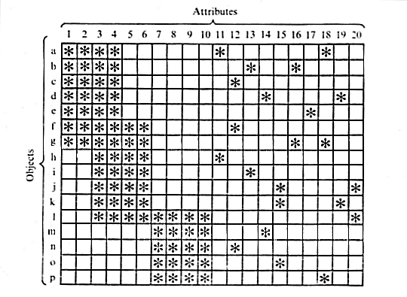
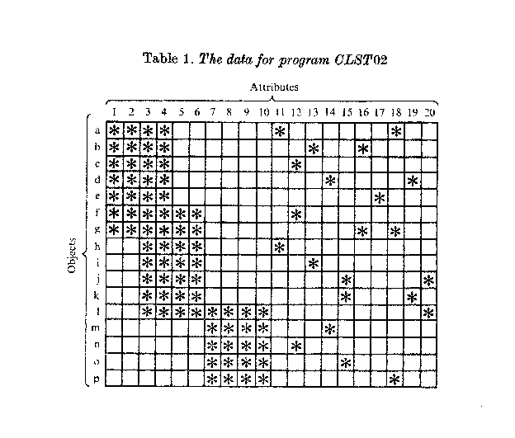ability is in ‘cloze’ procedure tasks in which missing letters or words in running text are to be supplied (see Miller & Friedman, 1958). As will be shown, the clustering and recognition programs can model the weaker sense of polythesis but not the stronger.
Weighting of attributes. Many methods in numerical taxonomy are criticized by taxonomists for not recognizing the intuitive fact that some attributes are more significant in the development of classes than others. The attributes ‘fur’, ‘four legs’ and ‘tail’ are weak determiners of the concept ‘cat’ while ‘retractile claws’ and certain features of the teeth are very strong.
The following section describes the clustering and recognition programs. Their relevance to these six features of human conceptual systems is discussed at relevant points.

THE MODEL — CLST02 AND RKLS02
The overall function of CLST02 is to sift out commonly co-occurring sets of attributes and to code less frequent sets of attributes in terms of their more frequent subsets whenever that is possible. The sets which are sifted out I have termed ‘maximally associated’ sets of attributes (MA-sets). A maximally associated set is defined as a set of attributes which occurs in a greater number of objects than any superset of that set (not an equal or lesser number). MA-sets are related to but not the same as maximally linked (ML) sets (Jardine & Sibson, 1971).
To illustrate the definition, consider the set of attributes (4, 11) in Table 1. These two attributes occur together in objects a and h and in no other objects. But the set of attributes (3, 4, 11) also occurs in these two objects. Since there is no other attribute
Frequency, conceptual 8tructure and pattern recognition 381

which is present in both objects then set (3, 4, 11) is an MA-set but set (4, 11) is not.
A point to note about this clustering process is that the frequency of co-occurrence of attributes depends on the frequency of occurrence of objects. In Table 1 each object type occurs only once but there is nothing to prevent any or all of them occurring two or more times. Such multiple occurrences will affect the conceptual structure formed by the program. It is assumed that the same is true of human concept formation.
For every MA-set of attributes there is a corresponding set of objects in which the given attributes occur. It may be remarked in passing that, as with certain other clustering methods, an ‘inverse’ analysis may be performed in which the roles of objects and attributes are interchanged. CLST02 seems to be unique amongst methods giving overlapping clusters in that both objects and attributes are clustered in both direct and inverse analyses and the clusters produced are the same in both analyses. (Lambert & Williams, 1962, and Tharu & Williams, 1966, have achieved approximate solutions in the case of methods producing non-overlapping clusters.) To avoid confusion the general term ‘element’ will be used for a MA-set of attributes. A ‘minimal element’ is a single attribute and a ‘composite element’ is an element containing more than one attribute.
The particular algorithm described here is probably only one of several possible ways of realizing the same process and makes no pretence at modelling neural processes in detail.
1. The input data is a set of ‘attribute lists’, i.e. lists of attributes, one for each object. The first step is to set up a n × n ‘frequency matrix’ (or equivalent linkage structure to save space) where n is the total number of attributes.
2. The cells of the matrix are filled with counts of the number of objects in which each pair of attributes co-occur.
3. The largest count is selected (or an arbitrary choice in the case of ties) and the corresponding pair of attributes is joined to form a new composite ‘attribute’. This is added to each of the appropriate attribute lists, i.e. those lists in which the two constituent attributes co-occur. These constituent attributes are not then deleted as might be expected. This is because they need to be left free to combine with other attributes later.
4. Each new element is assigned to a new node in a data structure with links connecting this node to the pre-established nodes for its two constituents. If, subsequently, it becomes a constituent of some other elements then further links connect its node to the nodes for these elements. This data structure, illustrated in Fig. 2, is formed on identical principles to that described in detail previously (Wolff, 1975) except that forwards and backwards links are not distinguished.
The frequency matrix is increased by one row and one column for the new composite attribute and the appropriate counts, taken from the attribute lists, are entered into the new cells with the following exceptions:
(a) The two cells corresponding to the pairing of the new element with each of its two immediate constituents.
If one or both of the immediate constituents are themselves composites (which is the rule in later stages of processing) then they each represent a set
26 PSY 67
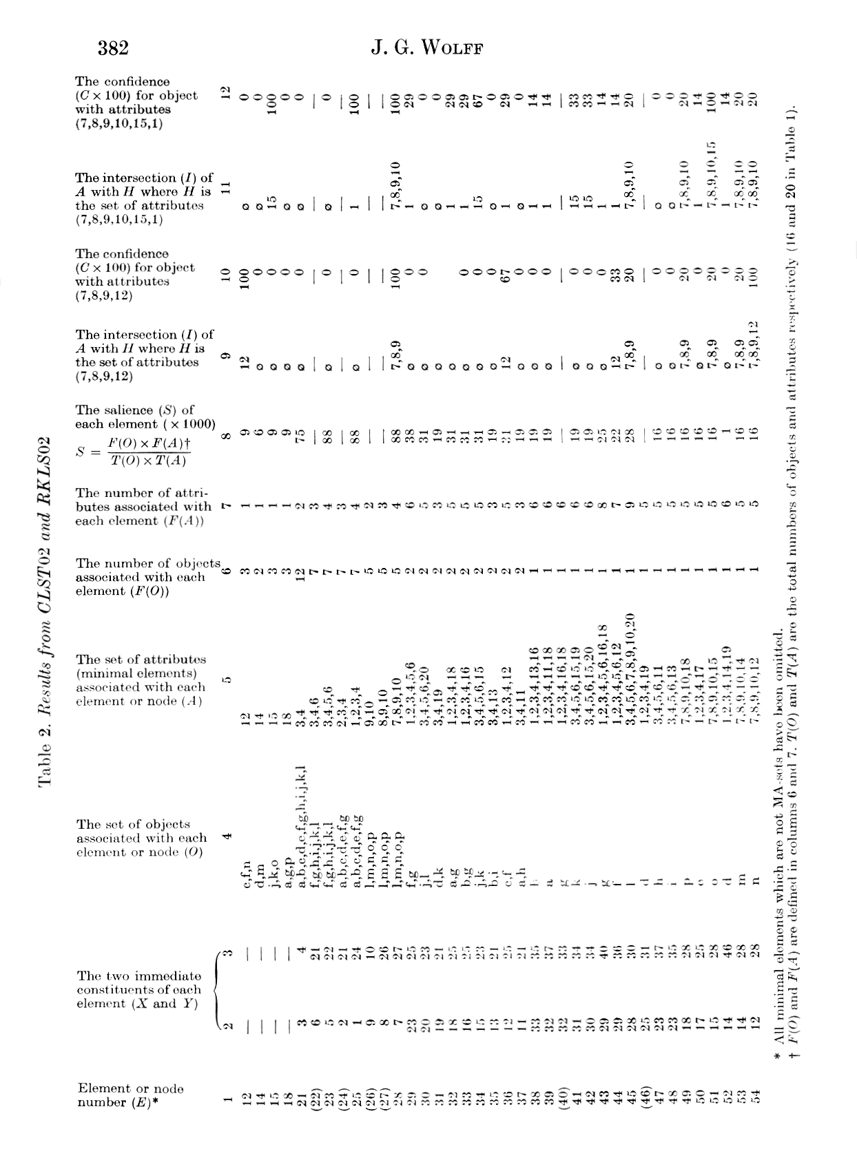
Frequency, conceptual structure and pattern recognition 383

of elements which includes the given main constituent, the constituents of that constituent, the constituents of those constituents, etc., down to the minimal elements. No counts are entered into the cells corresponding to pairings of the new element with all members of this set.
(b) In the same way, no counts are entered into the cells corresponding to all pairings of elements between the two sets represented by the two main constituents.
All the cells described in (a) and (b) are deleted or otherwise excluded from further consideration.
The procedure then returns to 3 and recycles repeatedly through 4, 5 and 3 until there are no cells left in the augmented frequency matrix containing counts greater than zero. The reason for pursuing the process down to the lowest frequencies is that it allows one to assign a structure to the attribute sets of single objects as will be shown. A point to note is that CLST02 can form associations between clusters which already have constituents in common. This is necessary to ensure that all MA-sets are found. An example appears in Fig. 2.

Illustrative result

The process may be illustrated with results from the artificial data shown in Table 1. These data are designed to cover points made in the introduction and to avoid the shortcoming in the ‘frequency of co-occurrence’ principle which has already been mentioned and which is discussed below.
CLST02 reveals all the MA-sets in the data and these are shown in Table 2 (column 5) with the addition of six (marked with brackets in column 1) which are not MA-sets but are intermediate clusters formed by the program in the course of building up MA-sets. Only elements 12, 14, 15 and 18 of the 20 minimal elements turn out to be themselves MA-sets and only these four are shown. Elements 21-54, numbered in column 1 in order of formation, are all built out of the two constituents, X and Y, shown in columns 2 and 3. Using these two columns the complete structure of any element may be traced as will be seen in a moment. Column 4(O) shows the objects corresponding to the attribute sets and columns 6 and 7 [F(O) and F(A)] record the size of the object and attribute sets respectively.
It will be noticed that the later-formed MA-sets correspond to the attribute sets of the objects themselves. The interest in this apparently trivial result is in the structure assigned to these sets, a representative selection of which are shown in Fig. 1.
Each element is shown by a blob or ‘node’ in the structure, the height of which shows the frequency of co-occurrence of the elements dominated by that node (or, for minimal elements, simple frequency of occurrence). Strictly speaking all elements apart from the minimal elements have a binary structure as, for example, element 28 which is built up as (7(8(9, 10))). However, where more than two constituents join at the same frequency the element is effectively ternary, or, as in this case, quaternary. Another point to note is that the structures shown in Fig. 1 are actually interlocked in a complete data structure a partial representation of which is shown in Fig. 2.
We are now in a position to see how this clustering process mirrors three of the properties of concepts outlined earlier:
Hierarchy. The hierarchical relation of clusters can be seen in Fig. 2 where
26-2
384 J. G. WOLFF
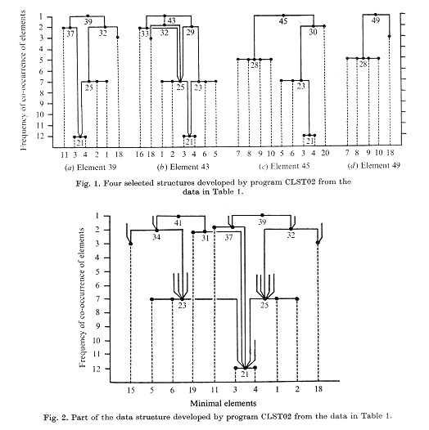
element 21 is a shared constituent of elements 23 and 25. In terms of the corresponding object sets, element 21 is a superordinate category while elements 23 and 25 are subordinate to it.
Overlap. It may be seen from Table 2 that the sets of objects for elements 23 and 28 have object 1 in common even though these two elements are not hierarchically related. This then is a case of overlap. In a similar way objects f and g are common to the object sets for elements 23 and 35. This same overlap may be seen in Fig. 1(b) where nodes 23 and 25 are both dominated by node 29 which is itself dominated by node 43. These examples of hierarchy and overlap may also be seen in Table 1.
Salience. We can define a measure of salience for each cluster by:


Frequency, conceptual structure and pattern recognition 385

where F(O) and F(A) have already been defined as the size of the object and attribute sets for the given cluster and T(O) and T(A) are the total numbers of objects and attributes respectively (i.e. 16 and 20 in Table 1). Values of S (× 1000) are shown in column 8 of Table 2 and it can be seen that the four highest values (for elements 21, 23, 25 and 28) correspond to groupings of attributes which are intuitively the most prominent in Table 1. This very tentative measure of salience has the desirable property of varying from 0 to 1 but more work would need to be done to establish the extent to which it reflects the psychological salience of clusters.

THE RECOGNITION PROGRAM — RKLS02

Supplementary to the development of a classification system is identification or diagnosis, the process by which new objects are recognized or assigned to one or more of the pre-established categories. A computer program, RKLS02, has been written to model this process and is described here.
The data structure developed by CLST02 is, apart from the lack of distinction between backwards and forwards links, exactly the same as that developed by program MK10E (Wolff, 1975). To recapitulate, each element (including the minimal elements) is assigned to a node in the data structure. Every time two elements are joined to form a new composite element then a link is created between the new element and each of the immediate constituents — two links in all. The ‘minor’ links described for MK10E and retained in CLST02, are merely a programming device to allow several links to emerge from one node. In MK10E the recognition process has the strength of suggesting how context can influence recognition but it is implausible as a model of human recognition because it cannot handle any combination of contextual elements, it is a serial process and it cannot recognize a pattern containing distortions. These three defects are remedied in RKLS02.
This program takes as its input the data structure developed by CLST02 from data such as those in Table 1 and also a list of the attributes of a new object to be assigned to one or more of the concepts embodied in the data structure. This list of attributes need not correspond exactly to any of the original lists.
The first step is the assignment of each attribute to its corresponding minimal element or node in the data structure. Although this is a template matching process it is justified on the grounds that any recognition system, however sophisticated, must necessarily employ such a process at its most fine-grained level.
Next, signals are sent from each of these nodes up through the data structure to all nodes that can be reached from that node. At each one a trace or record is left of the attribute from which the signal originated. In this way lists of attributes are accumulated at some or all nodes. This process of sending signals though the network may loosely be termed parallel processing because several signals may be travelling in the network at the same time. It is perhaps more accurate to call it independence processing because the signals are independent of each other and although they may travel simultaneously they need not; indeed, when the process is modelled on a serial computer they cannot.
If the set of minimal elements or attributes dominated by any given node is designated as A and the set of attributes of the new object is H then the list of attributes accumulated at each node is simply the intersection, I, of A with H (I = A ∩ H).

386 J. G. WOLFF

The set I for a given node may be found also at nodes having a higher F(O). If, of all nodes with the same I, the one with the highest F(O) is designated by the subscript j and the given node (which may be the same one) by the subscript i then a measure of ‘confidence’ that the new object belongs to the given node is taken to be simply:
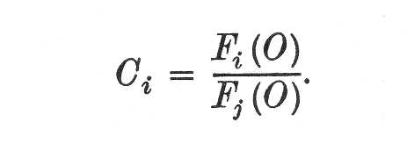
If set I is null then C_{i} is taken to be zero.
Strictly speaking, C is a conditional probability. It is the probability that the new object belongs in category i given that it contains the attribute set I. These ‘probabilities’ (shown in columns 10 and 12 of Table 2) do not add up to 100 per cent both because different categories have different sets I and also because some categories embrace or are embraced by others.
Imagine a new object having only attributes 7, 8, 9 and 12 (corresponding to the attributes of object n but with the omission of attribute 10). The sets I for this object are shown in column 9 of Table 2 and values of C in column 10. Most of the sets I are null and the corresponding nodes are not indicated in any way. Node 28, however, embraces three attributes and since no node having the same set I has a higher F(O) then the object is assigned to category 28 with a C of 100 per cent. Since the set A for this category is attributes 7, 8, 9 and 10 the program has in effect made an inductive prediction on the basis of past evidence that, given attributes 7, 8 and 9, attribute 10 should also be present in the object. The justification for induction, especially when it produces wrong predictions as in this case, is the province of philosophers (e.g. Blackburn, 1973); the fact remains that inductive processes figure prominently in human cognition—the expectation that a set of attributes should be found together in the future given that they have always occurred together in the past is one that most people would acknowledge as plausible.
In a similar way category 54, which is subordinate to category 28, is indicated with 100 per cent confidence in spite of the fact that one of its attributes is missing. The other four categories which are subordinate to category 28 (45, 49, 51 and 53) are each indicated with 20 per cent confidence. Since the five categories are mutually exclusive only one can be chosen and this is necessarily category 54, the one with the highest confidence.
Rather than the new object being the same as one of the original objects with the omission of one or more attributes it may be the same as one of the original objects but with the addition of one or more attributes. The simplest possibility is that these supernumerary attributes are themselves new and therefore unrecognizable. In this situation they are simply filtered out at the first stage in the recognition process which then proceeds normally using only the attributes from the original set. More usually the ‘noise’ which distorts a pattern is itself composed of part and whole patterns. In the case of speech it may be other speech superimposed; in printed text it might be added or substituted letters. With print it is easy to see that there is a kind of conflict between those letters (attributes) which indicate the correct pattern and those which are noise. Usually, as for example in PSYCHBOLOGY, the true pattern
Frequency, conceptual structure and pattern recognition 387

is easily seen but in other cases such as CAUT it is not possible without additional clues to say whether one is dealing with CAT or CUT.
As an example, using our original data, imagine an object having attributes 7, 8, 9,10, 15 and 1. The sets I and values of C are shown in columns 11 and 12 of Table 2. As one might expect the object is assigned to category 51 with a high degree of confidence, higher than for any other category having any or all of attributes 7, 8, 9, 10 or 15 in its set A. The effect of attribute 1 which is found in a relatively wide variety of categories is to determine most of these rather weakly with the single exception of category 25 which, like category 51, is indicated with a confidence of 100 per cent. This example is comparable with the CAT/CUT example given above. It is arguable that in PSYCHBOLOGY the B determines with 100 per cent probability the large class of words containing a B but this class is of such low salience, if it is recognized at all, that it seems to be completely discounted or ignored. However, category 25, although it covers a relatively wide range of subordinate categories, has been assigned a rather high salience and cannot be discounted in the same way. It seems that this aspect of the working of RKLSO2 is rather less satisfactory than its handling of omissions.
Having described the recognition system we can now consider how the last three proposed properties of conceptual/recognition systems are modelled:
‘Fuzziness’ of concept boundaries. This means that, for a given category, it is possible to find objects which are assignable to that category with less than complete confidence. This is clearly true of the model and to that extent this property of conceptual systems is covered.
Polythesis. Perhaps the strongest feature of this model is to suggest how omissions of attributes from patterns may be filled in on an inductive basis. It meets the weak polythetic requirement in that any subset of the set of attributes referable to a category may be used to predict the remaining attributes. Supernumerary attributes are also handled but less successfully.
It remains true, however, that the clusters formed are in a sense ‘defined’ both intensionally as a set of attributes and extensionally as a set of objects and such definition is inconsistent with the strong sense of a polythetic category (see Jardine, 1969, who prefers the term ‘family resemblance concept’).
Weighting of attributes. Fig. 1(d) shows the structure of element 49 corresponding to object p. It should be clear from this example that the presence of attribute 18 in an object is more powerful in identifying element 49 (C = 33 per cent) than any of attributes 7, 8, 9 or 10 (C =20 per cent). Such differences in weighting result naturally from the way the clustering process works without ad hoc provision.

GENERAL DISCUSSION AND CONCLUSION

We have seen that six significant properties of human conceptual/recognition systems are modelled with varying degrees of success. The other requirement, in accordance with schema theory, is that the clustering process should represent an efficient coding of the data. In order to assess the efficiency of coding we may assume that the coded data of Table 1 are stored as a set of nodes each node consisting of two or more ‘pointers’ pointing to the constituents of that node. Such a system would allow all nodes to be ‘unpacked’ to reproduce the sets of attributes of Table 1.

388 J. G. WOLFF
Table 3. Hypothetical data discussed in the text
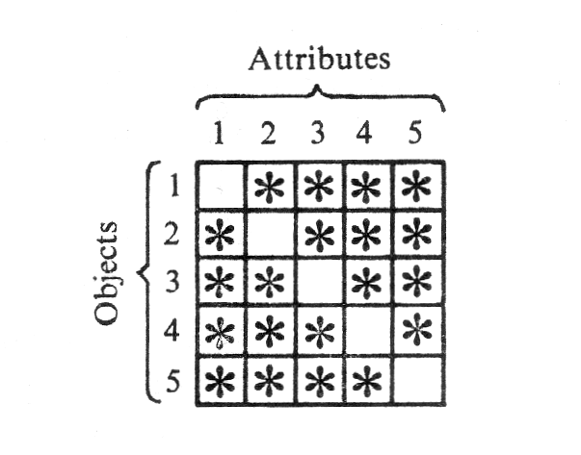
The minimum number of such pointers required in this case is 68 (2 × the number of composite elements) pointing to a maximum of 54 different nodes. So the minimum number of binary digits required for each pointer is log₂ 54 ≈ 6 and the total storage space required is 6 × 68 = 408 bits.
The data of Table 1 are in fact presented in only 320 two-state cells but this is only possible on the assumption that no attribute can occur more than once in any given object. If this assumption is abandoned then the simplest system for recording the data is a set of pointers, each signifying one attribute. For this data 94 such pointers would be required each needing log₂ 20 ≈ 5 bits of space. So the total storage space required is 5 × 94 = 470 bits. This is rather more than the figure of 408 bits computed above so it is clear that the clustering process does allow a modest economy in storage requirements in this case. If the number of objects was, say, 1000 but the number of basic patterns was still only 16 then dramatic economies become possible.
However if CLST02 is applied to the data shown in Table 3 no less than 30 MA-sets are isolated and the storage requirement calculated as before is about 350 bits. This compares most unfavourably with the simple pointer system requiring only about 60 bits. Such a set of objects could easily occur in our experience and it is most unlikely that we would employ such an inefficient coding system in this case. In fact it is intuitively clear that the most efficient coding would be achieved by assigning all five attributes to one node and coding the attributes of each object as the complete set minus one attribute.
Another way of expressing this problem is to say that the coding system employed in CLST02 is asymmetrical in the sense that it can only code an attribute set as one set with the addition of another rather than being able to code it either as one set with the addition of another or as one set with the subtraction of another. We may use the term ‘positive coding’ for the addition of one attribute set to another and ‘negative coding’ for the subtraction of one set from another and it seems that. both kinds of coding need to be available to effect economical storage of all types of data. It should be clear from the above example of negative coding that such a system would from time to time form ‘dummy’ nodes or concepts having attribute sets never found complete in any one object. Likewise no single attribute from such a set need be found in all the objects belonging to the concept. Such concepts would be polythetic in the strong sense.
Frequency, conceptual structure and pattern recognition 389

This work was conducted under the supervision of Dr Godfrey Harrison of University College, Cardiff. I am very grateful to him and also to Dr John Wilson of U.C.C. for useful discussions and for constructive comments on earlier drafts of this paper.

REFERENCES

ATTNEAVE, F. (1954). Some informational aspects of visual perception. Psychol. Rev. 61, 183 -193.
ATTNEAVE, F. (1957). Transfer of experience with a class-schema to identification-learning of patterns and shapes. J. exp. Psychol. 54, 81-88.
BERSTED, C. T. (1970). A general model of probabilistic concept formation. Unpublished doctoral dissertation, Texas Christian University.
BLACKBURN, S. (1973). Reason and Prediction. Cambridge: Cambridge University Press.
BOLTON, D. M. & WALI.ACE, C. S. (1970). A program for numerical classification. Comput. J. 13, 63-69.
BROWN, B. R. & EVANS, S. H. (1970). Further application of the random adaptive module (RAM) system to schema theory. Technical Memorandum 4-70, Human Engineering Laboratories, US Army Aberdeen Research and Development Centre, Aberdeen Proving Ground, Md.
BRUNER, J. S., GOODNOW, J. J. & AUSTIN, G. A. (1956). A Study of Thinking. New York: Wiley.
CHOMSKY, N. (1965). Aspects of the Theory of Syntax. Cambridge, Mass.: M.I.T. Press.
COLE, A. J. (ed.) (1969). Numerical Taxonomy. London: Academic Press.
EVANS, S. H. (1964). A model for perceptual category formation. Part I. Unpublished doctoral dissertation, Texas Christian University.
EVANS, S. H. (1967). A brief statement of schema theory. Psychon. Sci. 8, 87—88.
EVANS, S. H. & ELLIS, A. M. (1972). Annotated bibliography of reports on schema theory and related research. US Army Human Engineering Laboratories Technical Note, 1972 (Sept.).
JARDINE, N. (1969). A logical basis for biological classification. , Syst. Zool. 18, 37-52.
JARDINE, N. & SIBSON, R. (1971). Mathematical Taxonomy. New York: Wiley.
KISS, G. R. (1972). Grammatical Word Classes. A Learning Process and its Simulation. Edinburgh: MRC Speech and Communication Unit.
KLAUSMEIER, H. J., GHATALA, E. S. & FRAYER, D. A. (1974). Conceptual Learning and Development. A Cognitive View. London: Academic Press.
LAMBERT, J. M. & WILLIAMS, W. T. (1962). Multivariate methods in plant ecology. IV. Nodal analysis. J. Ecol. 50, 775-802.
McQUITTY, L. L. (1956). Agreement analysis: classifying persons by predominant patterns of responses. Br. J. statist. Psychol. 9, 5-16.
MILLER, G. A. & FRIEDMAN, E. A. (1958). The reconstruction of mutilated English texts. Inf. Control 1, 38-55.
NEEDHAM, R. M. (1963). A method for using computers in information classification. In C. M. Popplewell (ed.), Information Processing 1962: Proceedings International Federation for Information Processing Congress, Munich. Amsterdam: North-Holland.
OLDFIELD, R. C. (1954). Memory mechanisms and the theory of schemata. Br. J. Psychol. 45, 14-23.
OLIVIER, D. C. (1968). Stochastic grammars and language acquisition mechanisms. Unpublished doctoral dissertation, Harvard University.
POSNER, M. I. & KEELE, S. W. (1968). On the genesis of abstract ideas. J. exp. Psychol. 77, 353-363.
PREMACK, D. (1970). A functional analysis of language. J. exp. Analysis Behav. 14, 107-125.
ROMMETVEIT, R. (1968). Words, Meanings and Messages. London: Academic Press.
ROSCH, E. H. (1973). Natural categories. Cognit. Psychol. 4, 328-350.
SNEATH, P. H. A. & SOKAL, B. R. (1973). Principles of Numerical Taxonomy. San Francisco: Freeman.
SPÄRCK JONES, K. & JACKSON, P. M. (1967). Current approaches to classification and clump-finding at the Cambridge Language Research Unit. Comput. J. 10, 29-37.
SPÄRCK JONES, K. & JACKSON, D. M. (1970). Use of automatically-obtained keyword classifications for information retrieval. Inf. Storage 5, 175.
- J. G. WOLFF

THARU, J. & WILLIAMS, W. T. (1966). Concentration of entries in binary arrays. Nature, Lond. 210, 549.
UTTLEY, A. M. (1959). The design of conditional probability computers. Inf. Control 2, 1-24.
UTTLEY, A. M. (1970). The informon: a network for adaptive pattern recognition. J. theor. Biol. 27, 31—67.
WALLACE, C. S. & BOULTON, D. M. (1968). An information measure for classification. Comput. J. 11, 185-194.
WOLFF, J. G. (1975). An algorithm for the segmentation of an artificial language analogue. Br. J. Psychol. 66, 79-90.
ZAHN, C. T. (1971). Graph-theoretical methods for detecting and describing gestalt clusters. IEEE. Trans. comput. 20, 68-86.

(Manuscript received 11 October 1974; revised manuscript received 26 May 1975)

