Br. J. Psychol. (1975), 66, 1, pp. 79—90 79

Printed in Great Britain

AN ALGORITHM FOR THE SEGMENTATION OF AN
ARTIFICIAL LANGUAGE ANALOGUE

By J. G. WOLFF

University Hospital of Wales and University College, Cardiff

Hayes & Clark (1970) have demonstrated that adult subjects are capable of identifying the beginnings and ends of ‘words’ in artificial ‘speech’ when all clues from pause, stress or intonation are absent. This paper describes the mechanism and properties of a computer program which can perform an analogous segmentation of letter strings. Although the program contains artificialities, it seems to model other aspects of cognition besides perceptual segmentation: the use of redundancies to effect economies in storage and retrieval of information, induction, and the importance of context in recognition. The behaviour of the program and other evidence suggests that the joint probability of two perceptual elements provides a better definition of association than transition probability. The possible relevance of the program to the learning of grammatical patterns is briefly discussed.

Hayes & Clark (1970) constructed an ‘artificial speech analogue’ by assembling a limited set of artificial ‘phonemes’ into a small set of short strings (‘words’) and generating these strings in random sequence for as long as required. Tests showed that, after a period of listening to this artificial ‘speech’, adult subjects had, in varying degrees, learned to identify the beginnings and ends (boundaries) of the word segments although there were no cues from pause, intonation or correlation with entities outside the stream of sound. (Which is not to say that such cues do not contribute to the segmentation of natural speech.)
The main purpose of this paper is to describe and discuss the mechanism and properties of a computer program which can achieve an analogous segmentation of letter strings on punched cards. That segments of natural language similar to or the same as linguists’ phoneme, morpheme, word, phrase and sentence units are psychologically ‘real’ is an assumption made in this paper although formal demonstrations of this reality seem to have been made only for the major phrase units (e.g. Ladefoged & Broadbent, 1960; Johnson, 1965; Bever et al., 1969; Bertelson & Tisseyre, 1970; Levelt, 1970; Kennedy & Wilkes, 1971; Chapin et al., 1972) and there remains some doubt as to whether ‘surface’ structure or ‘deep’ structure is responsible for the effects observed. The dearth of studies attempting to show that words are psychologically real may be perhaps because their reality seems too obvious to require formal demonstration.
In discussing possible mechanisms to explain their observations Hayes & Clark describe a ‘subject’s eye view’ of the experiment: ‘the process seems to proceed roughly as follows. At first, the sound stream seems quite amorphous and featureless. After perhaps a minute of listening, an event -- perhaps a phoneme or part of a phoneme -- stands out of the stream. When the event has recurred several times, the listener may notice that it is typically preceded or followed by another event. The combination of events can in turn be related to events that happen in its neighbourhood. Recognition of a word, then, seems to proceed from perceptually distinctive foci outwards in both directions towards the word boundaries. Presumably, the

80 J. G. WOLFF

process would tend to stop at word boundaries because the correlations across the boundaries are weak’ (p. 227).
That the correlations between phonemes (and phones) within a word or morpheme are generally stronger than correlations between phonemes separated by a word or morpheme boundary has been discussed by Harris (1955) and amplified by Gammon (1969). This paper further explores the implications of this observation in a psychological context. Space does not permit a detailed comparison between the method employed here and those of Harris and Gammon.
The latest version of the computer program (MK1OE) is described with some illustrative results and brief reference is made to an earlier version. Properties of the program are then described and discussed in more detail. The paper ends with a general discussion of the program’s psychological relevance

THE PROGRAM

Outline description of analogue and program

A typical language analogue or text used as input for the program is constructed as a random sequence of words drawn with replacement from a small finite set (say 20) and punched on to computer cards using the Roman alphabet and ordinary spelling but without any punctuation, spaces or other markers of word boundaries. (e.g. HOWLIKESQUEEZESLEEPSQUEEZEALIKEONEXTRAJUICEAJUICEAMAUVEEXTRA...). The 26 letters of the alphabet may be roughly equated with phonemes but it would be more accurate to describe them as minimal elements comparable with perceptual elements simpler than phonemes, that is, phones or parts of phones. The term ‘element’ here covers both minimal elements and groups of minimal elements formed by the program.
Starting with only the 26 letters of the alphabet in its list of elements the program works from left to right through the text simply keeping a count of the joint frequencies of all pairs of contiguous elements (e.g. 1-2, 2-3, 3-4 etc.) A linkage structure (see Hays, 1967) is used for keeping count of different pairs rather than a simple matrix which would be very wasteful of storage space. The first pair to recur a certain fixed number of times (say 10) is added to the list of elements, all counts are set to zero and the counting process proceeds as before with the new element treated as a unit like the rest. The program may either start at the beginning of the text for each scan or may use new texts each time — the results are essentially the same in both cases.
An important feature of the program is that a sequence of letters which matches a given element can only be counted as an occurrence of that element if it does not occur in a context which makes it part of a larger element. This allows small words like IN or ON to be identified even though they may also form parts of larger words. The method of storing and recognizing elements is discussed later but before describing these details of the program it is as well to describe some results to illustrate how the program works.

Algorithm for segmentation of artificial language analogue 81

Table 1. Illustrative results from MK1OE

New elements formed* New elements formed*
N N

28. M,I 167 85. WEMISS,LIZ 5395
29. MI,S 177 86. THEYMISS,THEM 5416
30. MIS,S 178 87. YOU,WATCHLIZ 5463
31. E,S 232 88. IT,WATCHESBIILDS 5477
32. MISS,ES 330 89. JANE,MISSESIT 5571
33. T,H 344 90. JANE,WATCHESLIZ 5683
34. TH,E 345 91. YOUMISS,THEM 5709
35. W,A 351 92. JOAN,WATCHESLIZ 5760
36. WA,T 352 93. TOM,WATCHESTHEM 5870
37. WAT,C 353 94. IT,MISSESLIZ 5977
38. WATC,H 354 95. JOAN,MISSESLIZ 6016
39. I,T 363 96. MENMISS,IT 6149
40. L,I 420 97. MEN,WATCHIT 6255
41. L1,Z 421 98. JOAN,WATCHESIT 6268
42. WATCH,ES 430 99. THEYMISS,IT 6304
43. T,O 508 100. JOAN,WATCHESBIRDS 6469
44. TO,M 509 101. THEYMISS,LIZ 6526
45. B,I 572 102. YOUMISS,IT 6586
46. BI,R 573 103. IT,MISSESTHEM 6619
47. BIR,D 574 104. MENMISS,BIRDS 6631
48. BIRD,S 575 105. IT,MISSESBIRDS 6672
49. A,N 578 106. IT,WATCHESTHEM 6695
50. M,E 624 107. YOU,WATCHEIRD5 6718
51. ME,N 625 108. JANE,MISSESLIZ 6731
52. THE,M 645 109. JANE,WATCHESIT 6872
53. J,O 848 110. IT,WATCHESIT 7000
54. JO,AN 850 111. YOU,WATCHIT 7093
55. MEN,MISS 934 112. JANE,MISSESEIRDS 7123
56. Y,O 1037 113. WE,WATCHLIZ 7186
57. YO,U 1038 114. WE,WATCHIT 7576
58. J,AN 1072 115. TOM,WATCHESIT 7698
59. JAN,E 1073 116. JANE,MISSESTHEM 7872
60. MISSES,BIRDS 1192 117. YOU,WATCHTHEM 7999
61. WATCHES,BIRDS 1244 118. IT,WATCHESLIZ 8073
62. WATCH,IT 1325 119. T0M,MISSESTHEM 8327
63. W,E 1399 120. TOM,MISSESIT 8729
64. WATCHES,LIZ 1449 121. THEYMISS,BIRDS 9033
65. WATCH,LIZ 1498 122. THEY,WATCHLIZ 9127
66. THE,Y 1579 123. MENMISS,THEM 9353
67. MISSES,THEM 1653 124. JANE,WATCIIESTHEM 9384
68. THEY,MISS 1783 125. TOM,MISSESBIRDS 9526
69. WE,MISS 1794 126. THEY,WATCHTHEM 9928
70. MJSSES,LIZ 2146 127. MEN, WATCHBIRDS 10,096
71. MISSES,IT 2168 128. MEN,WATCHLIZ 10,107
72. WATCHES,IT 2238 129. THEY,WATCHIT 10,277
73. WATCHES,THEM 2280 130. MEN,WATCHTHEM 10,289
74. YOU,MISS 2297 131. JOAN, MISSESIT 10,310
75. WATCH,THEM 3004 132. WE,WATCHBIRDS 10,766
76. WATCH,BIRDS 3048 133. JANE,WATCHESBIRDS 10,837
77. MENMISS,LIZ 3488 134. JOAN,WATCHESTHEM 10,864
78. JOAN,MISSESBIRDS 3705 135. THEY,WATCHBIRDS 11,398
79. TOM,WATCHESLIZ 4020 136. IT,MISSESIT 11,854
80. WEMISS,BIRDS 4286 137. TOM,WATCHESBIRDS 12,136
81. WE,WATCHTHEM 5091 138. YOUMISS,LIZ 12,446
82. WEMI5S,IT 5203 139. YOUMISS,BIRDS 12,805
83. TOM,MISSESL1Z 5306 140. WEMISS,THEM 13,290
84. JOAN,MISSESTHEM 5346

* For convenience of programming the minimal elements, not shown in the table, were numbered from 2. The new elements: numbered from 28, are each formed from two constituents, separated here by a comma
82 J. G. WOLFF

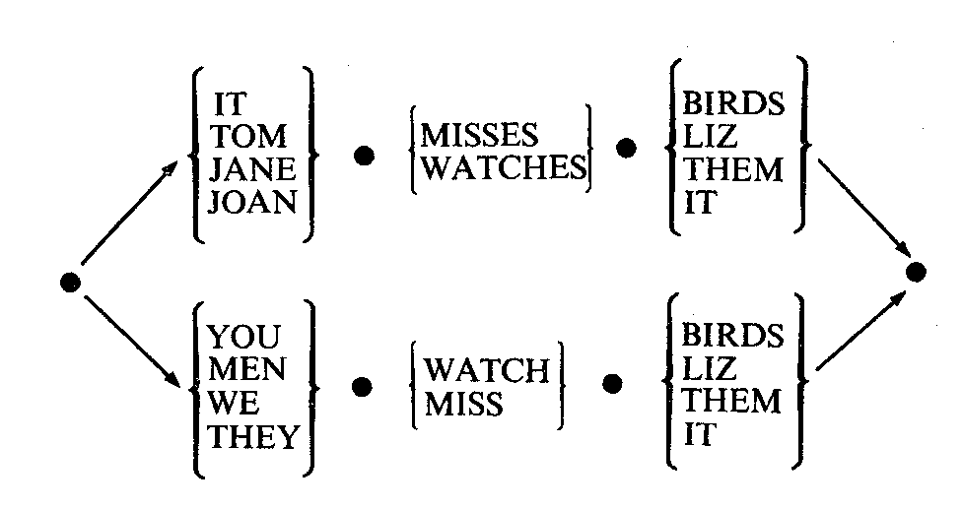

Sample:
ITMISSESBIRDSYOUWATCHL1ZMENMISSITTOMMISSESLIZ...

Fig. 1. A simple finite state grammar with a short sample. The resulting text
was used as input for MK1OE.

Illustrative results

In general, the new elements formed are only part words, whole words, or combinations of whole words. There are, with certain texts, a few anomalies which break this rule and these are described and discussed in a later section.
Table 1 shows the results produced by MK1OE applied, with a required count of 10, and starting at the beginning of the text for each scan, to a text prepared according to the simple finite state grammar shown in Fig. 1.
Each new element is listed with the value of N, the number of letters covered to find ten occurrences of that element. N is, in effect, a measure of the strength of association between left and right constituents of each element. Since the two constituents of each element are marked, it is possible to trace the full constituent structure of any element; this can be quantified using N as is shown in a moment.
All the elements after number 76 are complete sentences. All and only the 64 theoretically possible sentences have been produced. All the smaller structures — part words, words and pairs of words — have been assimilated into these 64 sentences. It has been established that the program required only a little over a quarter of the available text (13,290 out of 48,000 characters) to get this far but in the next scan exhausted all the 48,000 characters without finding a contiguous pair of sentences which occurred as many as 10 times. The association between any two sentences is thus very weak. This may be taken as evidence for the validity of the sentence boundaries.
Fig. 2 shows the internal structure of one typical sentence drawn as a tree diagram with N shown on the vertical axis using a logarithmic scale for clarity. In this case and in every other sentence produced, the three words in each sentence are topologically distinct. That is, junctions which cross word boundaries are only ever between whole words or between a pair of whole words and another whole word. In every case the weakest association marks one word boundary and the second weakest marks the other. If two separate partitions were introduced at random into the eight letter string of the shortest sentence (WEMISSIT) the probability of their being correctly placed would be 1/21. For the longer sentences this probability would be

Algorithm for segmentation of artificial language analogue 83

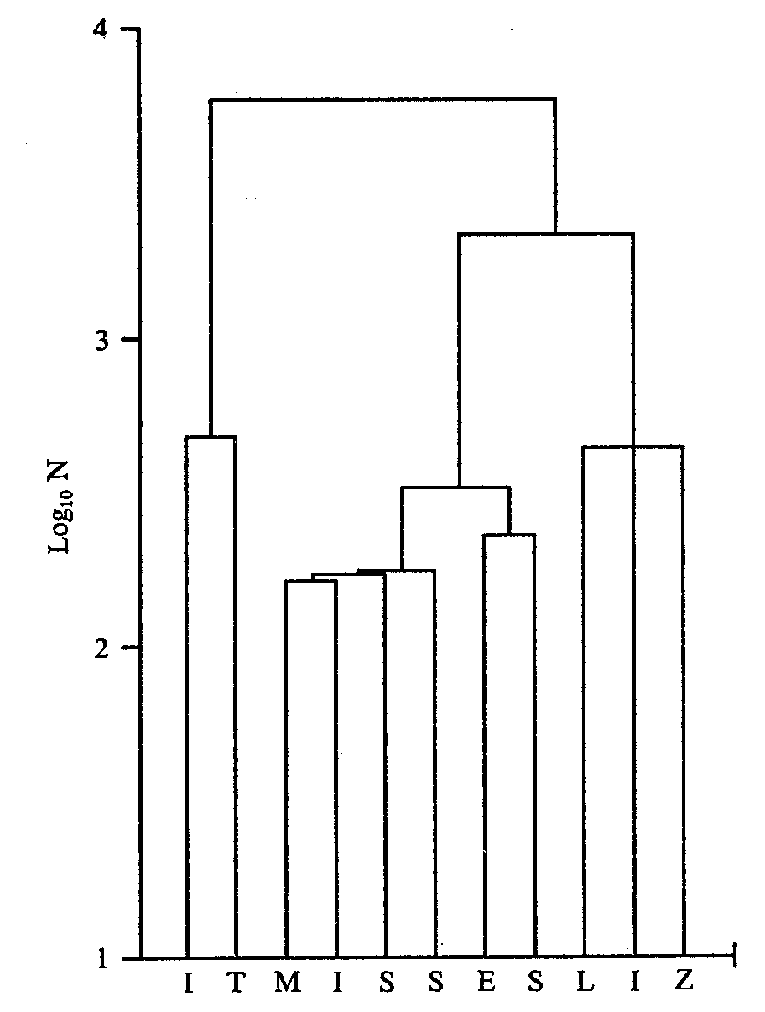

Fig. 2. A typical dendrogram (element 94) drawn from the results of a run of MX1OE
on the text of Fig. 1. The meaning of N is given in the text.

even smaller and the probability of all 64 sentences being correctly partitioned by chance is very small indeed (< 0.048⁶⁴).

Method of recognizing elements

An obvious method of recognizing elements is an alphabetic dictionary look-up system but there is a considerable gain in efficiency to be made through using the probability information being gathered by the program.
Fig. 3 shows part of the linkage structure used to store and recognize the elements of Table 1. At the beginning of the text analysis the tree is merely the basal chain of 26 letters arranged in order of absolute probability through a preliminary sampling of the text. After the first scan MI is attached to the node for M through a ‘major’ forwards link and to the node for i through a ‘major’ backwards link (not shown in the diagram). Similarly, major links are used to build up elements 29 (MI,S), 30 (MIS,S) 32 (MISS,ES) and 60 (MISSES,BIRDs). When other elements are formed in which MISSES is the left-hand element, they are connected to the node for element 60 in a chain of ‘minor’ links. The logical result of this system is that the right-hand elements (BIRDS, THEM, LIZ and IT in this example) are always in descending order of transition probability from the common left-hand element and left-hand elements are similarly arranged with respect to common right-hand elements. Major links
84 J. G. WOLFF

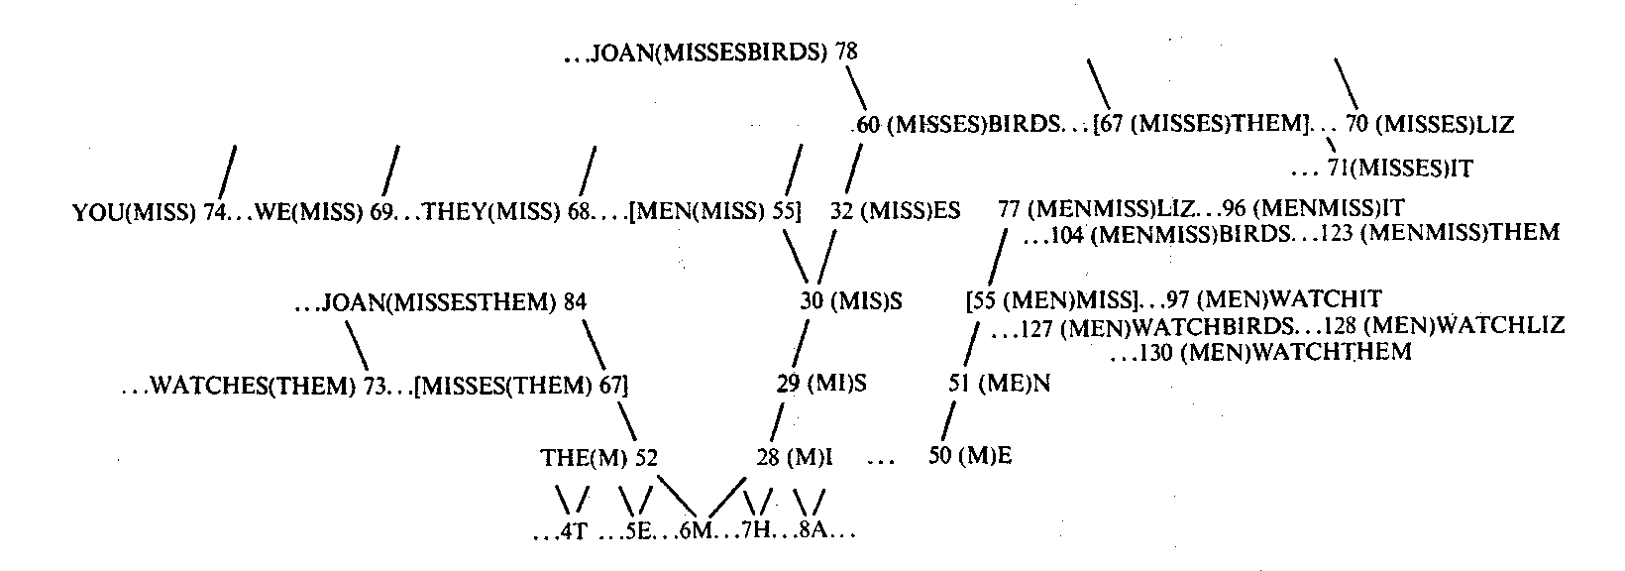

Fig. 3. Part of the data structure used to store and recognize the elements of Table 1. Maj- or forwards and backwards links are right and left leaning lines respectively. Horizontal dotted lines are minor links. Although elements 55 and 67 are each shown twice, only one node is used for each.

handle syntagmatic relations in the text while minor links are concerned with paradigmatic relations.
In recognizing MENWATCHBIRDS, for example, the program compares the first letter (M) with the first basal node (S, which does not appear in Fig. 3) and with successive basal nodes until it finds a match at the node for M (node 6). Then it moves along the major forwards link to node 28 and checks whether the next letter is I. This fails so it moves along the minor link from 28 to 50 and tests whether the next letter is E. Having identified ME it moves along the major forwards link to node 51 and checks whether the next letter is N. This matches so it tests the four letters, MISS (node 55). Failing on this one it moves down the chain of minor links to node 97 and checks the letter sequence WATCHIT which also fails to match; it then checks WATCHBIRDS (node 127) where it finds a match. The lack of major links from node 127 in this case (or, in other cases, failure to make a match at the next level up the tree) identifies element 127 as the largest element at this location in the text. In checking groups of letters it is, of course, unnecessary to continue checking after the first mismatch.

An earlier version of the Programme

Originally, the notion of correlation’ was identified with transition probability, as is implicit in Harris’s and Gammon’s studies, and a program (MK04) which was constructed to pick out contiguous pairs with backwards or forwards transition probabilities greater than 0.25 was successful in that all and only the 20 words of a random text (A, I, LAZY, SHOCK, SHOCKS, JAZZY, QUEEN, PANSY, INSTRUCTION, INSTRUMENTATION, PYJAMA, GARGOYLE, GINGHAM, WAXED, DRAFT, IN, MASSIVE, ON, AN, GONE) were identified as words on the criterion of transition probabilities between each of these 20 elements and anything else being less than 0.25. However, this version produced large numbers of anomalous elements bridging word boundaries all of which were eliminated by a check in the program requiring elements to occur with a certain minimal frequency before they could be considered ‘legitimate’. Many duplicates were produced and some elements were constructed which, owing to the asymmetry of the transition probability measure of association, were actually
Algorithm for segmentation of artificial language analogue 85

unrecognizable by the recognition routine being used. MK1OE applied to the same text produced very few anomalous elements, no duplicates and no unrecognizable elements. On this evidence, transition probability is a much less satisfactory definition of association than absolute, joint probability. In this connection Asch & Ebenholtz (1962) have shown that associational links are generally symmetrical. Joint probability meets this requirement while transition probability does not.

Some more properties of MK1OE

To illustrate how MK1OE behaves in different situations, here are brief descriptions and discussion of the results obtained with different texts.
Twenty-word random text. This text was constructed as a random sequence of words drawn with replacement from a set of 20 (A, I, JUICES, JUICE, ABLE, LIKE, LIKEABLE, POLLUTION, FACTION, LIBERATION, MUNITION, RAT, SLEEP, PROPERTY, SQUEEZE, FUDGE, HOW, MAUVE, EXTRA, ON). Within the set time limit of 15 minutes 186 elements were produced of which 20 were these whole words, 50 were part words, 112 were pairs of whole words, 1 was a pair of whole words joined to a single whole word and the following eight were anomalous: [((RAT)(A))(BLE)], [((FACTION)(A))(BLE)], [((LIKE)(JUICE))(S)], [((JUICE)(A))BLE)], F((SLEEP)(JUICE))(S)], [((MAUVE)(JUICE))(S)], [(JUICES)(LEEP)], [((FUDGE)(JUICE))(S)]. These anomalies are discussed below. Two general points can be made:
1. Seventeen of the words, including some like RAT, ON, I, ABLE and LIKE which are also parts of larger words, behave as coherent wholes in a variety of contexts. The exceptions, JUICES, ABLE and SLEEP, appear in the eight anomalous elements but are also found as independent units too.
2. An element like TION which occurs in four of the twenty words, appears as a distinct structural entity within those words. However, in each of these four words its association with the rest of the word is much stronger than the association of the whole word with anything else.
In the same way, LIKE and ABLE, when they are not behaving as words in their own right, appear as distinct divisions within the word LIKEABLE and, again, the association between LIKE and ABLE in LIKEABLE is much stronger than between LIKEABLE and anything else (including LIKE or ABLE).
Gammon (1969) suggested that ‘there are degrees of distributional freedom and that instead of hoping to give an absolute distributional characterization of the word, we should speak of degrees of distributional wordhood’ (p. 56). The behaviour of elements like TION, LIKE and ABLE (and ES in Fig. 2) has obvious relevance to the concept of a morph.
Unbalanced frequencies. Characteristically the frequencies of different words in natural language vary widely, the variation usually following Zipf’s law (1935). To see what effect unbalanced frequencies might have on the working of the program, a random text was prepared of five words (RED, ORANGE, YELLOW, GREEN, BLUE) in the ratios 9:7:2:1:1. The program quickly built up these five words which then behaved as coherent wholes in a variety of contexts without any anomalies.
Natural language. MK1OE has been run on a sample of natural language from Paul Gallico’s novel, ‘Jennie’ but, because of the relatively great variety of structures in natural language, regularities take a good deal longer to be revealed than with
86 J. G. WOLFF

artificial texts. The results from a 30 mm. run, with a required count of 10 and starting from the beginning of the text on each scan, can be summarized as follows: 193 elements were produced of which 64 were recognizable as words used in the text; 86 were parts of words used in the text; eight were clear combinations of whole words: [(TO)(THE)], [(HE)(HAD)], [(IT)(WAS)], [(HE)(WAS)], [(AND)(THE)], [(IN)(ME)], [(OF)(THE)], and [(TO)(BE)]. The other eight elements were more or less clearly anomalous. Of these, four seemed to be combinations of part with whole words: [(TO)(F)], [(D)(TO)], [(SO)(F)] and [(S)(AND)] and the rest [(AC)(AT)], [(ME)((D)(TO))], [(TA)(ND)], [(IN)((TO)(THE))] were anomalous in other ways. Some of these eight (e.g. SOF, SAND, TAND) could be part or whole words in English but did not appear to be used as such in this particular text.
Anomalies. The present method of recognizing elements explains many of the anomalies. For simplicity of programming, the recognition system always proceeds from left to right in the text using only the forwards links and tries always to find the largest element which can match the text. Usually, this works satisfactorily but, in the case of the 20-word random text described above, a sequence like RATABLE is correctly segmented only so long as only RAT and ABLE are in the store of elements but when RATA is formed (as a legitimate combination of the words RAT and A) then RATABLE will be segmented as RATA, B, LE. Subsequently, B and LE are joined to form BLE and this is then tacked on to RATA to form [(RATA) (BLE)]. All the other anomalies from the 20-word text and two (ACAT and TAND) from the natural language text can be explained in this way.
This problem is essentially that of ambiguity in perception. The recognition system in MK1OE needs to be adapted so that it can take account of strengths of association and see that, for example, in the sequence RATABLE the middle A which could belong either to RAT or BLE is in fact more strongly associated with BLE than with RAT. Such an adaptation may bring the backwards links into play.
All other anomalies can probably be explained in terms of sample size. With all the artificial texts, a required count of 10 is sufficient for perfect segmentation except for the anomalies discussed above. If this required count is made small enough, then other types of anomaly appear in which bits of words are joined to other whole words or to bits of words and the segmentation of the text is revealed only poorly or not at all. It seems likely that a required amount of 10 is too small for natural language, at least in the early stages, and that most if not all of the other anomalies would disappear with a bigger count.

DISCUSSION

The process described seems generally sufficient to explain Hayes & Clark’s results and awaits critical comparison with other hypotheses having that status. However, it is not intended to try to ‘prove’ the hypothesis even if that were logically possible but rather to offer the mechanism as a heuristic to guide further investigation. The strengths and weaknesses of this program are first discussed and its possible relevance to the learning of grammatical patterns is briefly considered.
On the positive side the program is in tune with a number of fairly well-established
Algorithm for segmentation of artificial language analogue 87

psychological principles. One of these is that because there is far more information impinging on an organism than it can possibly assimilate, there are considerable advantages in recoding that information to reduce or eliminate redundancies (Attneave, 1954; Miller, 1956); given evolution by natural selection an efficient mechanism is a priori more probable than an inefficient one. Considerable economies in both storage and retrieval are obtained by treating high correlating pairs of elements as unitary elements. Because the program does this and thus, in effect, sifts out the redundancies in the text due to correlation and unbalanced probabilities it has been termed a ‘redundancy net’.
Economy in retrieval is related to another prominent feature of human cognition — induction or ‘going beyond the information given’ (Bruner, 1957). By using contextual probabilities to predict letter sequences the recognition process is speeded up. This is a form of ‘analysis-by-synthesis’ the case for which has been argued by Halle & Stevens (1962) among others. The general sensitivity of human recognition to context is well known (e.g. Miller & Selfridge, 1950; Miller et al., 1951; Treisman, 1960; McNicol & Howes, 1971). The extensive literature on probability matching testifies to our ability to gather statistical information about our environment.
Amongst the weaknesses of the program not already mentioned is the fact that it builds structures only along the single dimension of time and cannot accommodate the kinds of patterns, in more than one dimension, which seem to occur in speech. (This field is outlined by Denes & Pinson, 1963.) Related to this is the fact that the elements created by the program are rigidly invariant patterns unlike phonemes which are clusters of allophones or words which are also clusters of similar patterns. (It is conceivable, however, that a similar clustering process could account for these paradigmatic groupings.)
No account is taken of meanings although the correlation of speech segments with extra-linguistic entities probably helps segmentation or will influence the details of segmentation structures and the sequence in which they are produced. A similar correlation process may help explain the learning of referential meanings at least, if not of other forms of meaning. Incidentally, the term ‘entity’ is used here to cover any coherent percept whether it be object, action or quality, etc. and its use entails the assumption that something similar to our clustering process is at work not only within the speech stream, and between the speech stream and the non-speech world, but within that non-speech world also. (On this last point see Hayes & Clark, 1970.)
Another unnatural feature of the program is the sudden and rigid joining of elements after 10 co-occurrences. It is more plausible to suppose that the brain forms tentative structures on the basis of early evidence which can be adjusted later as fuller information becomes available. Again, a recognition system which tests possible patterns in sequence is less plausible on a priori and on empirical grounds (e.g. Saraga & Shallice, 1973) than an independence or parallel processing model. Such a model (e.g. Selfridge, 1959) has the advantage of recognizing patterns in spite of distortions. Far from a parallel model being incompatible with the use of probabilistic information in recognition the implicit use of such information is partly responsible for its flexibility.
Turning to the last general question, the fact that language contains clusters bigger than words, namely phrases and sentences, suggests that the principles
88 J. G. WOLFF

embodied in the program may have a bearing on the formation of these structures too and thus on the general problem of the learning and use of grammar. In fact, the program may be considered to be one possible realization of Osgood’s (1963)’ integration principle’ proposed as a possible mechanism for developing phrase structure and tested by Stolz (1965). It should be noted that Osgood and Stolz distinguish the variables of frequency and redundancy whereas here no distinction is made. Whether MK1OE can identify phrase groupings more successfully than the method used by Stolz remains to be seen. Only two of the related problems will be discussed briefly here: the problems of grammatical classification and of discontinuous constituents.
The notion of grammatical classes (nouns, verbs, noun phrases, etc.) originates in linguistics but also has a place in psychological theories of how we may generalize from observed patterns and thus generate new combinations of words (e.g. Braine, 1963). We have seen that MK1OE requires a classification system to accommodate the fact that language is composed of sequences of classes of patterns rather than sequences of specific patterns.
Kiss (1972) has produced a program which classifies words of natural language purely on the basis of shared context and which ultimately produces groupings which are very similar to linguists’ categories of noun, verb, adjective, etc. Fig. 3 shows that the data structure of MK1OE also classifies elements by shared context and that four elements (BIRDS, THEM, LIZ, IT) with the same left context (MISSES) form one of the classes used in constructing the text (see Fig. 1) and another four elements (YOU, WE, THEY, MEN) form another class. Word combinations are also classified. The possibility seems to exist to develop this system in such a way as to produce polythetic rather than monothetic classes (Sokal & Sneath, 1963) and to allow the syntagmatic clustering process to operate on these classes rather than on specific patterns. There is also the possibility of amplifying contextual generalization theories of language generation. In this connection it is worth observing that a structure of the form: 'the {very* | fast} car', where * signifies the class {very* | fast}, allows infinite recursion or iteration (see Reich, 1969).
From the data structure developed by the program it is possible to deduce the strengths of association between pairs of elements which are not connected explicitly. Thus, for example, the strength of association between IT and ES in element 94 (Fig. 2) is much stronger than between IT and MISSESLIZ, MISSES or MISS. This is essentially an example of discontinuous dependencies as discussed by Chomsky & Miller (1963, p. 286). When one considers that at least one of the examples given to justify the transformational view of grammar (Chomsky, 1957, pp. 38—42) is based on discontinuous correlations (e.g. be … ing) it appears that there is not necessarily as much conflict between statistical and transformational views of language structure as has sometimes been supposed.
In summary it is suggested that a syntagmatic clustering process using conjoint probabilities already has explanatory power for certain aspects of language learning and has potential bearing on a number of other problems in the field.

This study was supervised by Dr Godfrey Harrison of University College, Cardiff. I am very grateful to him for his encouragement and for his constructive criticism of earlier drafts of this paper. I am also indebted to Dr Donald Broadbent for comments on an earlier version of this

Algorithm for segmentation of artificial language analogue 89

program, and for drawing my attention to Reich’s paper and to the problem of retaining the coherence of small structures which are also part of larger structures.
Note added in proof. As this paper goes to press Dr Harrison has found an account by Brown (1973) of an otherwise unpublished study by Olivier (1968) which presents a model of language segmentation having points of similarity to the one described here.

REFERENCES

ASCH, S. B. & EBENHOLTZ, S. M. (1962). The principle of associative symmetry. Proc. Am. Phil. Soc. 106, 135—163.
ATTNEAVE, F. (1954). Some informational aspects of visual perception. Psychol. Rev. 61, 183-193.
BERTELSON, P. & TISSEYRE, F. (1970). Perceiving the sequence of speech and non-speech stimuli. Q. J. exp. Psychol. 22, 653-662.
BEVER, T. G., LACKNER, J. R. & KIRK, R. (1969). The underlying structures of sentences are the primary units of immediate speech processing. Percept. Psychophys. 5, 225—234.
BRAINE, M. D. S. (1963). On learning the grammatical order of words. Psychol. Rev. 70, 323-348.
BROWN, R. W. (1973). A First Language: the Early Stages. London: Allen & Unwin.
BRUNER, J. S. (1957). Going beyond the information given. In J. S. Bruner (ed.), Contemporary Approaches to Cognition. Cambridge, Mass.: Harvard University Press.
CHAPIN, P. G., SMITH, T. S. & ABRAHAMSON, A. A. (1972). Two factors in perceptual segmentation of speech. J. verb. Learn, verb. Behav. 11, 164-173.
DENES, P. B. & PINSON, E. N. (1963). The Speech Chain. New York: Bell Telephone Laboratories.
CHOMSKY, N. (1957). Syntactic Structures. The Hague: Mouton.
CHOMSKY, N. & MILLER, G. A. (1963). Introduction to the formal analysis of natural languages. In R. D. Luce, R. R. Bush & E. Galanter (eds.), Handbook of Mathematical Psychology. New York: Wiley.
GAMMON, B. (1969). Quantitative approximations to the word. Tijd.sch. Inst. Toegepaste Linguistiek (Leuven) 5, 43-61.
HALLE, M. & STEVENS, K. N. (1962). Speech recognition: a model and a program for research. I.R.E. Trans. Inf. Theory IT-8 (2), 155-159.
HARRIS, Z. S. (1955). From phoneme to morpheme. Language 31, 190-222.
HAYES, J. R. & CLARK, H. H. (1970). Experiments on the segmentation of an artificial speech analogue. In J. R. Hayes (ed.), Cognition and the Development of Language. New York: Wiley.
HAYS, D. G. (1967). Introduction to Computational Linguistics. London: MacDonald.
JOHNSON, N. F. (1965). The psychological reality of phrase structure rules. J. verb. Learn, verb. Behav. 4, 469-475.
KENNEDY, B. A. & WILKES, A. L. (1971). Functional structure in sentences? A performance analysis. Q. J. exp. Psychol. 23, 214-224.
KISS, G. B. (1972). Grammatical Word Classes: a Learning Process and its Simulation. Edinburgh: M.R.C. Speech and Communications Unit.
LADEFOGED, P. & BROADBENT, D. B. (1960). Perception of sequence in auditory events. Q. J. Exp. Psychol. 12, 162—170.
LEVELT, W. J. M. (1970). Hierarchical chunking in sentence processing. Percept. Psychophys. 8, 99—102.
MCNICOL, D. & HOWES, P. M. (1971). The effect of context on the perception of speech. Aust. J.. Psychol. 23, 305-310.
MILLER, G. A. (1956). The magical number seven, plus or minus two: some limits on our capacity for processing information. Psychol. Rev. 63, 8 1-97.
MILLER, G. A., HEISE, G. A. & LICHTEN, W. (1951). The intelligibility of speech as a function of the text of test materials. J. exp. Psychol. 41, 329-335.
MILLER, G. A. & SELFRIDGE, J. A. (1950). Verbal context and the recall of meaningful material. Am. J. Psychol. 36, 176-185.
OLIVIER, D. C. (1968). Stochastic grammars and language acquisition mechanisms. (Unpublished Ph.D. thesis, Harvard University.)
OSGOOD, C. E. (1963). On understanding and creating sentences. Am. Psychol. 18, 735-75 1.
REICH, P. A. (1969). The finiteness of natural language. Language 45, 831-843.

90 J. G. WOLFF

SARAGA, E. & SHALICE, T. (1973). Parallel processing of attributes of single stimuli. Percept. Psychophys. 13, 261-270.
SELFRIDGE, O. G. (1959). Pandemonium: a paradigm for learning. In L. Uhr (ed.), Pattern Recognition. New York: Wiley.
SOKAL, B. R. & SNEATH, P. H. A. (1963). Principles of Numerical Taxonomy. San Francisco: Freeman.
STOLZ, W. (1965). A probabilistic procedure for grouping words into phrases. Lang. & Speech 8, 219-235.
TREISMAN, A. M. (1960). Contextual clues in selective listening. Q. J. exp. Psychol. 12, 242-248.
ZIPF, G. K. (1935). .The Psycho-biology of Language. Boston, Mass.: Houghton Mifflin.

(Manuscript received 26 August 1973; revised manuscript received 22 February 1974)

